A Major Project Phase - 1 Report On
DEEP TEMPORAL MODELING FOR RICE LEAF DISEASE RECOGNITION USING TCN-GRU
In partial fulfillment of the requirements for the award of the degree
Of
MASTER OF TECHNOLOGY
In
DATA SCIENCES

Submitted by,

MALAVATH SINDHU (23211A6768)

Under the Guidance of
Dr Ch. Vengaiah
Assistant Professor, Computer Science and Engineering (Data Science)


B V RAJU INSTITUTE OF TECHNOLOGY
(An UGC Autonomous Institution, Approved by AICTE, New Delhi & Affiliated to JNTUH, Hyderabad) Vishnupur, Narsapur, Medak, Telangana, India 502313

2026 -2027


B V RAJU INSTITUTE OF TECHNOLOGY

Vishnupur, Narsapur, Medak, Telangana, India 502313

BONAFIDE CERTIFICATE

This is to certify that this mini project work entitled “DEEP TEMPORAL MODELING FOR RICE LEAF DISEASE RECOGNITION USING TCN-GRU”, submitted by MALAVATH
SINDHU(23211A6768) to B V Raju Institute of Technology affiliated to JNTUH, Hyderabad in partial fulfillment for the award of Master of Technology in DATA SCIENCES is a bonafide record of project work carried out under our supervision during the academic year 2025 – 2026 and that this work has not been submitted elsewhere for a degree.

SIGNATURE
Dr Ch.Vengaiah Supervisor
Assistant Professor, CSD

SIGNATURE
Dr R.V. Ramana Chary Head of the Department Professor, CSD

Submitted for Major Project Phase-1 viva-voce examination held on

INTERNAL EXAMINER EXTERNAL EXAMINER




B V RAJU INSTITUTE OF TECHNOLOGY
Vishnupur, Narsapur, Medak, Telangana, India 502313

DECLARATION

I hereby declare that the project titled “DEEP TEMPORAL MODELING FOR RICE LEAF DISEASE RECOGNITION USING TCN-GRU”, submitted to B V RAJU INISTITUTE OF
TECHNOLOGY (Autonomous) and affiliated with JNTUH, Hyderabad, in partial fulfillment of the requirements for the award of a Master of Technology in DATA SCIENCES, represents my ideas in my own words. Wherever other’s ideas or words have been included, I have adequately cited and referenced the original sources. I also declare that I have adhered to all principles of academic honesty and integrity, and I have not misrepresented, fabricated, or falsified any idea, data, fact, or source in my submission. I understand that any violation of the above will be a cause for disciplinary action by the Institute. It is further declared that the project report or any part thereof has not been previously submitted to any University or Institute for the award of degree.

Signature(s)

MALAVATH SINDHU 23211A6768

Place: Date:


B V RAJU INSTITUTE OF TECHNOLOGY
Vishnupur, Narsapur, Medak, Telangana, India 502313
ACKNOWLEDGEMENT

I would like to express my sincere gratitude to the Management of BVRIT Narsapur, Dr. K. LakshmiPrasad, Director and Dr. Sanjay Dubey, Principal for providing excellent infrastructure, necessary facilities, and a conducive academic environment for carrying out this Major Project Phase-1 successfully.

My sincere thanks and gratitude to Dr. R.V. Ramana Chary, Professor & Head of the Department of CSD for all the timely support and valuable suggestions during the period of Major Project Phase-1.

I am thankful to our Project Coordinator Dr Ch. Vengaiah, Assistant Professor, Department of CSD for his cooperation during the project work.

I am greatly thankful and indebted to our internal guide, Dr Ch.Vengaiah, Assistant Professor, Department of CSD for his/her constant guidance, encouragement and moral support throughout the Major Project Phase-1.

Finally, I would also like to thank all the faculty and staff of the CSD Department who helped us directly or indirectly, parents and friends for their cooperation in completing Major Project Phase-1.

MALAVATH SINDHU 23211A6768

INDEX

ABSTRACT vi

LIST OF ABBREVATIONS vii
LIST OF FIGURES viii
LIST OF TABLES xi
Chapter Description Page. No
- INTRODUCTION 01
  - Motivation 02
  - Problem Statement 03
  - Objectives 04
  - Organization of the Report 05
- LITERATURE SURVEY 6
  - Introduction 7
  - Methodology from Previous Papers 8
  - Existing System 9
  - Existing Disadvantages 11
  - Proposed System 13
  - Advantages of Proposed System 15
- SYSTEM DESIGN 16
  - Introduction 17
  - Methodology 19
    - Data Collection 21
    - Data Preprocessing 24
    - Feature Extraction using CNN 27
    - Temporal Feature Modelling using TCN 28
    - Sequential Learning using GRU 29
    - Classification Layer 30
    - System Workflow 31
- IMPLEMENTATION AND RESULTS 32
  - Introduction 33

  - Explanation of Key Functionalities 34
    - Image Input and Dataset Handling 35
    - Image Preprocessing 36
    - Feature Extraction using CNN 38
    - Sequential Feature Modelling using TCN 39
    - Context Learning using GRU 40
    - Disease Classification 42
  - Method of Implementation 43
    - Software Requirements 44
    - Hardware Requirements 45
    - Sample Code Implementation 45
  - Output Screens 46
  - Result Analysis 54
- TESTING 54
  - Introduction 55
  - Testing Objectives 56
  - Types of Testing Performed 57
    - Functional Testing 58
    - Data Validation Testing 59
    - Model Validation Testing 59
    - Performance Testing 60
    - Confusion Matrix Analysis 61
    - Prediction Testing 61
  - Design of Test Cases 62
  - Testing Results 62
  - System Validation 63
  - Summary 64
- CONCLUSION AND FUTURE ENHANCEMENT 65
  - Conclusion 66
  - Limitations of the Proposed System 68
  - Applications of the Proposed System 69
  - Future Enhancement 70
  - Scope of Future Research 71
REFERENCES 75

PUBLICATION

ABSTRACT

Rice is one of the most important staple crops worldwide and plays a vital role in global food security; however, its production is significantly affected by various leaf diseases that reduce crop yield and quality. Early and accurate detection of these diseases is essential to minimize agricultural losses and support sustainable farming practices. Traditional disease identification methods rely on manual inspection, which is time-consuming, labor-intensive, and prone to human error. This study proposes an automated rice leaf disease detection system using a hybrid deep learning approach that integrates Convolutional Neural Networks (CNN), Temporal Convolutional Networks (TCN), and Gated Recurrent Units (GRU). Initially, rice leaf images are preprocessed through resizing, normalization, and data augmentation to enhance model robustness. A CNN-based feature extractor captures spatial characteristics such as color, texture, and lesion patterns, which are then modeled using a Temporal Convolutional Network to learn sequential dependencies. A GRU layer further refines contextual relationships among features, improving classification performance. Finally, a Softmax layer predicts the disease category among four classes: Bacterial Blight, Blast, Brown Spot, and Tungro. Experimental results demonstrate that the proposed CNN–TCN–GRU model achieves high accuracy in rice leaf disease classification, providing a fast, reliable, and automated tool to assist farmers and agricultural experts in early disease detection and improved crop management.

Keywords: Rice Leaf Disease Detection, Deep Learning, CNN, Temporal Convolutional Network (TCN), GRU, Image Classification, Precision Agriculture.

LIST OF ABBREVATIONS

AI | Artificial Intelligence
CNN | Convolutional Neural Networks
DL | Deep Learning
GPU | Graphics Processing Unit
GRU | Gated Recurrent Unit
ML | Machine Learning
ReLU | Rectified Linear Unit
TCN | Temporal Convolutional Network
TF-IDF | Term Frequency – Inverse Document Frequency

 | LIST OF FIGURES
Figure. No | Description | Page. No
3.1 | SYSTEM ARCHITECTURE | 20
3.2 | SAMPLE RICE LEAF IMAGES | 22
3.3 | IMAGE PREPROCESSING AND AUGMENTATION | 25
3.4 | CNN ARCHITECTURE | 29
3.5 | TCN ARCHITECTURE | 30
3.6 | GRU ARCHITECTURE | 31
4.1 | TRAINING ACCURACY GRAPH | 45
4.2 | TRAINING LOSS GRAPH | 46
4.3 | CONFUSION MATRIX | 48
4.4 | PREDICTION OUTPUT- | 49

4.5
4.6
4.7
BACTERIAL BLIGHT 50
BLAST DISEASE
TUNGRO DISEASE 51
BROWN SPOT DISEASE 52

LIST OF TABLES

Table. No | Description | Page. No
Table 4.1 | Software Requirements | 53
Table 4.2 | Hardware Requirements | 54
Table 4.3 | Performance Evaluation Metrics for Rice | 49
 | Leaf Disease Classification Model
Table 5.1 | Test Case Design for Rice Leaf Disease Recognition | 55

CHAPTER-1
INTRODUCTION

Motivation

Rice diseases are one of the major challenges faced by farmers in agricultural production. Early detection and diagnosis of plant diseases are essential to minimize crop damage and ensure higher productivity. In many rural areas, farmers may not have immediate access to agricultural experts who can diagnose plant diseases accurately. As a result, diseases may remain undetected for long periods, leading to severe crop losses. Manual inspection of rice leaves is also labour-intensive and time-consuming, especially when large agricultural fields need to be monitored regularly. Moreover, human observation may not always be accurate due to variations in disease symptoms, lighting conditions, and environmental factors. The rapid growth of artificial intelligence and deep learning technologies provides an opportunity to develop automated systems that can assist farmers in identifying plant diseases quickly and accurately. Image-based disease detection systems can analyze leaf images and recognize disease patterns without requiring extensive human intervention. The motivation behind this project is to design and develop an intelligent system that can detect rice leaf diseases automatically using deep learning techniques. By integrating CNN, TCN, and GRU models, the proposed system aims to improve classification accuracy and provide reliable disease detection results.Such a system can support farmers by enabling faster diagnosis of crop diseases and helping them take timely corrective actions. Ultimately, this can contribute to improved crop management, increased agricultural productivity, and enhanced food security.In addition to these benefits, the proposed system aims to reduce the dependency on expert knowledge and make disease detection accessible to farmers with minimal technical expertise. By providing an automated and easy-to-use solution, the system can bridge the gap between advanced technology and practical agricultural needs.

Furthermore, early and accurate disease detection helps in reducing the excessive use of pesticides, which can have harmful effects on the environment and human health. By identifying diseases at an early stage, farmers can apply targeted treatments, thereby promoting sustainable agricultural practices. Another important motivation for this project is to leverage modern computational techniques to address real-world problems in agriculture. The integration of deep learning models such as CNN, TCN, and GRU not only enhances prediction accuracy but also demonstrates the potential of hybrid models in solving complex image classification tasks. Finally, this project aims to contribute to the

advancement of precision agriculture, where data-driven approaches are used to optimize farming practices. By implementing an intelligent disease detection system, the project supports the vision of smart farming and technological innovation in the agricultural sector.

Problem Statement

Rice crops are frequently affected by various diseases that significantly reduce agricultural productivity. Early detection of these diseases is essential for effective crop management and prevention of large-scale crop damage. However, traditional disease detection methods rely heavily on manual inspection by agricultural experts, which is often slow, expensive, and not always accessible to farmers in remote areas.
Existing automated plant disease detection systems mainly use Convolutional Neural Networks (CNNs) for image classification. While CNN models are effective at extracting spatial features from images, they generally treat images independently and do not consider relationships between extracted features. This limitation can reduce the effectiveness of disease detection models when dealing with complex visual patterns.Therefore, there is a need for a more advanced system that can capture both spatial and sequential relationships in image features to improve disease classification accuracy. The proposed project addresses this challenge by developing a hybrid deep learning model that integrates CNN, Temporal Convolutional Networks (TCN), and Gated Recurrent Units (GRU) to enhance the detection of rice leaf diseases.In addition to these challenges, variations in image conditions such as lighting, background noise, leaf orientation, and resolution further complicate the disease detection process. These factors can affect the performance of traditional models, making it difficult to achieve consistent and reliable results across different environments.Another issue is the imbalance and diversity of datasets, where some disease classes may have more samples than others. This imbalance can lead to biased predictions and reduced accuracy for underrepresented classes. Therefore, the system must be robust enough to handle such variations and still maintain high performance.
Moreover, many existing systems lack scalability and real-time applicability. They are often designed for controlled environments and may not perform effectively in real-world agricultural settings. There is a need for a system that can be easily deployed and used by farmers without requiring complex infrastructure or technical expertise.The proposed hybrid approach not only aims to improve classification accuracy but also focuses on

building a reliable and generalizable model that can perform well on unseen data. By combining CNN with TCN and GRU, the system leverages both spatial feature extraction and sequential learning capabilities, thereby addressing the limitations of standalone models. Ultimately, the problem addressed in this project is the development of an efficient, accurate, and scalable rice leaf disease detection system that can assist farmers in making timely and informed decisions, leading to better crop management and increased agricultural productivity

Objectives

The main objectives of this project are as follows:
    - To develop an automated system for detecting rice leaf diseases using deep learning techniques.
    - To collect and preprocess rice leaf images for training and testing the disease detection model.
    - To extract meaningful spatial features from rice leaf images using Convolutional Neural Networks.
    - To model sequential relationships between extracted features using Temporal Convolutional Networks.
    - To refine contextual feature dependencies using Gated Recurrent Units.
    - To classify rice leaf diseases into four categories: Bacterial Blight, Blast, Brown Spot, and Tungro.
    - To evaluate the performance of the proposed model using metrics such as accuracy, precision, recall, and F1-score.

Organization of the Report

The project report is organized into several chapters to provide a structured explanation of the proposed system and its implementation.

Chapter-Introduction:
This chapter provides an overview of the project, including background information, motivation, problem statement, objectives, and the organization of the report.

Chapter2-LiteratureSurvey:
This chapter reviews existing research work related to plant disease detection using machine learning and deep learning techniques. It discusses various approaches used by previous researchers and highlights the limitations of existing methods.

Chapter3 – System Design:
This chapter explains the architecture and design of the proposed system. It describes the dataset, preprocessing techniques, deep learning architecture, and the overall workflow of the disease detection system.

Chapter4 – Implementation and Results:
This chapter presents the implementation details of the system, including the software tools and technologies used. It also discusses the training process, experimental results, and performance evaluation of the model.

Chapter 5 – Testing:
This chapter describes different testing methods used to evaluate the functionality and reliability of the system. It includes test cases and validation results.

Chapter 6 – Conclusion and Future Scope:
This chapter summarizes the overall findings of the project and highlights possible improvements and future research directions.

CHAPTER-2
LITERATURE SURVEY

Introduction
Plant diseases are one of the major factors affecting agricultural productivity and crop quality. In rice cultivation, diseases such as bacterial blight, blast, brown spot, and tungro can significantly reduce yield and cause economic losses for farmers. Early detection of these diseases is essential to prevent the spread of infection and to take timely preventive measures. Traditionally, rice leaf diseases are identified through manual inspection by agricultural experts. This process involves visual observation of leaf symptoms such as spots, discoloration, and lesions. Although manual diagnosis can provide reliable results when performed by experienced specialists, it is time-consuming and not always accessible to farmers, especially in rural areas. In addition, human observation may sometimes lead to incorrect diagnosis due to similarities between symptoms of different diseases.
In recent years, the rapid advancement of machine learning and deep learning technologies has enabled researchers to develop automated systems for plant disease detection using image processing techniques. These systems analyze images of plant leaves and identify diseases based on visual features such as color, texture, and shape patterns.Among the various approaches, Convolutional Neural Networks (CNNs) have been widely used for plant disease detection due to their ability to automatically extract complex visual features from images. Many studies have successfully applied CNN-based models to classify plant diseases with high accuracy. However, traditional CNN models focus mainly on spatial features and treat each image independently.To overcome this limitation, recent research has explored hybrid deep learning architectures that combine CNNs with sequential models such as Long Short-Term Memory (LSTM) networks, Gated Recurrent Units (GRU), and Temporal Convolutional Networks (TCN). These hybrid models help capture relationships between features and improve classification performance.This chapter reviews existing research work related to rice leaf disease detection using deep learning techniques and discusses the limitations of current approaches.

Methodology from Previous Papers

Several researchers have proposed different techniques for detecting rice leaf diseases using machine learning and deep learning approaches. These methods aim to automatically identify plant diseases by analyzing leaf images and extracting important visual patterns associated with different infections.
One of the earliest approaches involved traditional image processing techniques combined with classical machine learning algorithms. In these methods, researchers manually extracted features from leaf images using techniques such as color histograms, texture analysis, and edge detection. Color features were used to identify changes in leaf pigmentation caused by diseases, while texture features helped detect irregular patterns or lesions on the leaf surface. Edge detection algorithms were used to identify boundaries of infected regions. Once these features were extracted, machine learning classifiers such as Support Vector Machines (SVM), k-Nearest Neighbors (KNN), Decision Trees, or Random Forests were used to classify the diseases. Although these techniques produced reasonable classification results, they required manual feature engineering, which made the process complex and less adaptable to different datasets.With the rapid development of deep learning techniques, Convolutional Neural Networks (CNNs) became the most widely used method for plant disease detection. CNNs are highly effective in image recognition tasks because they automatically learn hierarchical features from images. Instead of manually designing features, CNN models learn relevant patterns directly from the data during the training process. The lower layers of a CNN detect basic features such as edges and textures, while deeper layers identify more complex patterns such as lesion shapes and disease structures. Furthermore, CNN-based models are capable of handling large-scale datasets and can generalize well when trained with diverse image samples. They are also robust to minor variations in image conditions such as rotation, scaling, and noise. However, standard CNN models primarily focus on spatial feature extraction and may not fully capture relationships between features across different regions of the image.
Many researchers have used popular deep learning architectures such as VGG16, ResNet50, DenseNet, InceptionNet, and MobileNet for plant disease classification. These architectures are often trained using transfer learning, where pre-trained models trained on large image datasets are adapted for plant disease detection.

For example, the DeepRice framework used a modified VGG16 architecture to detect rice leaf diseases by analyzing visual symptoms such as color variations, lesion shapes, and texture patterns present on infected leaves. The model achieved high classification accuracy and demonstrated that deep learning methods can effectively identify crop diseases using image data.Another research study proposed a system that combines image segmentation and classification techniques. In this approach, image segmentation algorithms are first used to isolate the infected regions of the leaf from the background. By focusing only on the diseased areas, the classification model can analyze the most relevant information, leading to improved disease detection accuracy.
Some researchers have also explored hybrid deep learning models that combine CNNs with recurrent neural networks such as Long Short-Term Memory (LSTM) networks. In these architectures, CNN is used to extract spatial features from images, while LSTM networks analyze sequential relationships among these features. This approach allows the model to capture contextual dependencies between features, improving the classification performance. More recently, researchers have introduced Temporal Convolutional Networks (TCN) as an alternative to traditional recurrent models. TCN uses dilated causal convolutions to capture long-range dependencies within sequential data while maintaining efficient parallel computation. When integrated with CNN-based feature extraction, TCN models can effectively analyze sequences of spatial features and identify complex disease patterns. Another promising approach involves integrating CNN with Gated Recurrent Units (GRU). GRU networks are designed to capture sequential dependencies in data while requiring fewer parameters compared to LSTM networks. The simplified architecture of GRU allows faster training and lower computational complexity while maintaining strong performance in sequence modelling tasks.
In addition to these methods, recent studies have also explored attention mechanisms and transformer-based models to further enhance feature representation. Attention mechanisms help the model focus on the most important regions of the image, thereby improving interpretability and accuracy. Although these approaches are computationally intensive, they show promising results in complex classification tasks. Overall, previous research studies indicate that combining spatial feature extraction with sequential learning mechanisms significantly improves the accuracy and robustness of plant disease detection

systems. These hybrid architectures form the foundation for advanced disease detection.

The insights gained from these studies highlight the importance of integrating multiple deep learning techniques to overcome the limitations of individual models. This forms the basis for the proposed approach in this project, which combines CNN, TCN, and GRU to achieve superior performance in rice leaf disease detection.

Existing System
Existing plant disease detection systems mainly rely on traditional agricultural practices or simple machine learning and deep learning models. In conventional farming methods, farmers usually detect plant diseases through manual inspection of crops. This involves visually examining plant leaves and identifying symptoms such as leaf spots, discoloration, lesions, and abnormal growth patterns. Agricultural experts use their experience and knowledge to determine the type of disease affecting the crop and recommend suitable treatments. Although manual inspection is a widely used method, it has several limitations. Accurate diagnosis requires significant expertise and experience in plant pathology. Farmers in remote or rural areas may not have immediate access to agricultural specialists, which makes disease identification difficult. Additionally, manual inspection is time- consuming and may not be practical for monitoring large agricultural fields.
To address these challenges, researchers have developed automated plant disease detection systems using machine learning and deep learning techniques. Many of these systems use image processing techniques combined with classification algorithms to identify plant diseases from leaf images. The process typically involves capturing images of plant leaves using cameras or mobile devices, preprocessing the images, extracting important features, and finally classifying the disease using machine learning models.
Earlier automated systems used traditional machine learning algorithms such as Support Vector Machines (SVM), Decision Trees, Random Forests, and k-Nearest Neighbors (KNN). These models relied on manually extracted features such as color histograms, texture patterns, and shape descriptors. Although these approaches provided moderate classification accuracy, they required careful feature engineering and were not always capable of capturing complex visual patterns present in plant diseases.With the advancement of artificial intelligence, deep learning-based systems have become the most commonly used approach for plant disease detection. Convolutional Neural Networks

(CNNs) are particularly effective for image classification tasks because they automatically learn hierarchical features directly from images. In CNN-based systems, convolution layers extract spatial features from the input images, pooling layers reduce the dimensionality of feature maps, and fully connected layers perform classification. Many existing systems use pre-trained CNN architectures such as VGG16, ResNet50, DenseNet, and Inception networks for plant disease classification. These models are often trained using transfer learning, where the knowledge learned from large image datasets is applied to agricultural datasets.Despite their effectiveness, most existing deep learning models focus primarily on spatial feature extraction and treat each image as an independent input. They do not explicitly model relationships between different feature regions within the image. As a result, these systems may struggle to identify complex disease patterns that appear across multiple regions of a leaf.

Existing Disadvantages
Although many automated plant disease detection systems have been developed in recent years, several limitations still exist in current approaches. One of the main disadvantages of many existing systems is their heavy reliance on spatial feature extraction using Convolutional Neural Networks. While CNN models are highly effective at identifying visual patterns in images, they primarily focus on local spatial information. This means that they may fail to capture complex relationships between different regions of the leaf where disease symptoms may appear in distributed patterns. Another limitation is that many models treat each image as an independent input without considering contextual relationships between extracted features. In real-world scenarios, disease symptoms often develop gradually and appear in structured patterns across different parts of the leaf surface. Ignoring these relationships can lead to incorrect classification, especially when different diseases share similar visual characteristics.Existing systems also face challenges related to dataset limitations. Deep learning models generally require large datasets with thousands of labelled images to achieve high accuracy. However, collecting and labelling large agricultural datasets can be difficult and time-consuming. In many cases, datasets may contain imbalanced classes, where some diseases have significantly fewer samples than others. This imbalance can affect model performance and lead to biased predictions. Another disadvantage is the high computational cost associated with training deep learning

models. Complex neural network architectures require powerful computing resources such as GPUs for efficient training. This can limit the adoption of such systems in regions where advanced hardware infrastructure is not readily available.
Environmental factors also pose challenges for automated disease detection systems. Variations in lighting conditions, shadows, background objects, camera angles, and image quality can affect the performance of image classification models. A model trained under controlled conditions may not perform well when applied in real agricultural environments where images are captured using mobile devices in natural lighting.Finally, many existing systems focus only on disease classification and do not provide additional support such as disease management recommendations or preventive measures. For practical agricultural applications, farmers require not only disease identification but also guidance on how to manage and prevent the detected disease. In addition to these limitations, many models suffer from overfitting, especially when trained on limited or less diverse datasets. Overfitting occurs when the model performs well on training data but fails to generalize to new, unseen data. This reduces the reliability of the system in real-world applications. Another issue is the lack of interpretability in deep learning models. Most models function as “black boxes,” meaning it is difficult to understand how the model arrives at a particular decision. This lack of transparency can reduce trust among users, especially farmers who may prefer understandable and explainable results.
Scalability is also a concern in existing systems. Many models are developed for specific datasets or limited disease categories and may not easily adapt to other crops or additional diseases. This restricts their applicability in broader agricultural scenarios. Moreover, real- time implementation remains a challenge. Many existing models are not optimized for deployment on mobile devices or low-power systems, making it difficult to use them directly in the field. Efficient and lightweight models are required for real-time disease detection. Lastly, integration with agricultural advisory systems is often missing. A complete solution should not only detect diseases but also integrate with platforms that provide recommendations, weather analysis, and crop management strategies. The absence of such integration limits the overall usefulness of existing systems.

Proposed System
To address the limitations of existing plant disease detection methods, this project proposes a hybrid deep learning framework for rice leaf disease detection that integrates Convolutional Neural Networks (CNN), Temporal Convolutional Networks (TCN), and GRU.The proposed system is designed to analyze rice leaf images and accurately classify them into different disease categories. The overall workflow of the system consists of multiple stages including image preprocessing, spatial feature extraction, sequential feature modeling, and classification. The first stage of the proposed system is image preprocessing. Raw images of rice leaves are collected from the dataset and processed to improve their quality and consistency. Preprocessing includes resizing images to a fixed dimension so that they can be processed by the neural network. Pixel values are normalized to improve training stability, and data augmentation techniques such as rotation, flipping, brightness adjustment, and scaling are applied to increase dataset diversity. In addition to these steps, preprocessing also helps in reducing noise and improving the clarity of important features present in the images. This ensures that the model focuses on relevant patterns rather than background variations, leading to better learning and improved accuracy. After preprocessing, the images are passed to a Convolutional Neural Network that performs spatial feature extraction. The CNN automatically learns important visual features such as edges, textures, lesion patterns, and color variations associated with different rice leaf diseases. These spatial features represent the structural characteristics of disease symptoms present on the leaf surface.
The CNN layers are designed to progressively extract low-level to high-level features, enabling the model to understand both simple and complex patterns. This hierarchical learning capability makes CNN highly effective for image classification tasks. The extracted features are then processed using a Temporal Convolutional Network. Unlike traditional CNN models that analyze features independently, TCN models treat the extracted features as sequences and analyze relationships between them. The TCN uses dilated causal convolutions that allow the network to capture long-range dependencies between features while maintaining computational efficiency. The use of TCN enhances the model’s ability to understand how different features are related across the image. This is particularly useful in disease detection, where symptoms may not appear in a single localized region but may be spread across the leaf. Following the TCN layer, the system incorporates a Gated Recurrent Unit (GRU) network to further refine the learned feature representations. The GRU is a type

of recurrent neural network that uses gating mechanisms to control the flow of information through the network. It helps the model retain important information while discarding irrelevant details, improving the ability of the system to distinguish between visually similar diseases. GRU also offers advantages such as faster training and lower computational complexity compared to other recurrent models like LSTM. This makes the proposed system more efficient while maintaining high performance. The final stage of the system is the classification layer, which uses a fully connected neural network with a Softmax activation function. The Softmax layer converts the extracted features into probability scores for each disease class and predicts the most likely disease category.
In addition, regularization techniques such as dropout may be used in the classification layer to prevent overfitting and improve the generalization capability of the model. This ensures that the system performs well not only on training data but also on unseen test data.
The proposed system is capable of classifying rice leaf images into four major disease categories:
    - Bacterial Blight
    - Blast
    - Brown Spot
    - Tungro
By combining CNN-based spatial feature extraction with TCN and GRU-based sequential feature modeling, the proposed system can capture both local and global patterns present in rice leaf images. This hybrid architecture improves the accuracy and robustness of disease detection compared to traditional CNN-based models. Furthermore, the integration of multiple deep learning techniques allows the system to overcome the limitations of individual models and achieve better performance in complex classification tasks. The proposed system also has the potential to support precision agriculture by providing an intelligent tool for early disease detection. Farmers can use such systems to identify crop diseases quickly and take timely preventive measures to reduce crop losses and improve agricultural productivity.
In addition, the system can be extended for real-time applications by integrating it with mobile or web-based platforms. This would allow farmers to capture images using smartphones and receive instant disease predictions.
Overall, the proposed system represents an advanced and efficient solution for automated rice leaf disease detection, combining accuracy, scalability, and practical usability.

Advantages of Proposed System
The proposed rice leaf disease detection system offers several significant advantages over traditional and existing automated methods. By integrating Convolutional Neural Networks (CNN), Temporal Convolutional Networks (TCN), and Gated Recurrent Units (GRU).
One of the primary advantages of the proposed system is its ability to capture both spatial and sequential features from rice leaf images. CNN is highly effective in extracting spatial features such as edges, textures, and color variations, while TCN and GRU help in modeling relationships between these features. This hybrid approach enables the system to detect complex disease patterns that may not be easily identified using standalone models.
Another important advantage is improved classification accuracy. By combining multiple deep learning techniques, the system reduces the limitations of individual models and enhances prediction performance. The use of sequential learning allows the model to better understand dependencies between features, leading to more reliable disease identification. The proposed system also reduces the need for manual inspection. Traditional disease detection methods require expert knowledge and are time-consuming. In contrast, the automated system provides fast and accurate predictions, helping farmers and agricultural experts make timely decisions. Scalability is another key benefit of the system. The model can be easily extended to include additional disease categories or adapted for other crops by retraining with new datasets. This makes the system flexible and suitable for future advancements in agricultural technology.Furthermore, the system is designed to handle real- world variations such as changes in lighting, background noise, and image quality. Data preprocessing and augmentation techniques improve the model’s robustness, allowing it to perform well in practical environments. The integration of deep learning with agricultural applications also supports precision farming. By enabling early detection of diseases, the system helps reduce crop losses, optimize pesticide usage, and improve overall productivity. In addition, the proposed system has the potential to be deployed as a mobile or web-based application. This would allow farmers to upload images directly from the field and receive instant predictions, making the technology accessible and user-friendly. Overall, the proposed system provides a powerful, efficient, and scalable solution for rice leaf disease detection, combining accuracy with practical usability.

CHAPTER-3
SYSTEM DESIGN

Introduction
System design is an important phase in the development of any intelligent application as it defines the architecture, structure, and workflow of the proposed system. In the context of this project, the system design focuses on building an automated deep learning–based framework capable of detecting and classifying rice leaf diseases from images.
The proposed system is designed to analyze images of rice leaves and identify disease types using a hybrid deep learning architecture that combines Convolutional Neural Networks (CNN), Temporal Convolutional Networks (TCN), and Gated Recurrent Units (GRU). The overall system integrates image preprocessing techniques, feature extraction methods, and deep learning classification algorithms to produce accurate disease predictions.The system follows a structured pipeline that begins with collecting rice leaf images from the dataset. These images are preprocessed to ensure consistency in size, quality, and format. Preprocessing steps such as resizing, normalization, and data augmentation help improve the robustness of the deep learning model by reducing noise and increasing dataset diversity.In addition to basic preprocessing, advanced techniques may also be applied to improve the quality of input data. These include contrast enhancement, noise reduction, and background removal, which help the model focus on the most relevant parts of the leaf image. Such improvements play a crucial role in enhancing the overall performance of the system.After preprocessing, a Convolutional Neural Network is used to extract spatial features from the images. CNNs are highly effective in analyzing visual data because they can automatically learn important features such as edges, textures, and patterns from images.The CNN architecture typically consists of multiple convolutional layers, activation functions, and pooling layers that progressively reduce the spatial dimensions while increasing feature depth. This allows the network to capture both low-level and high- level features efficiently.Once spatial features are extracted, they are passed to a Temporal Convolutional Network. The TCN analyzes sequential dependencies between the extracted features using dilated convolutions. This enables the model to capture relationships between different regions of the leaf image.
The advantage of using TCN lies in its ability to handle long-range dependencies while maintaining parallel computation, which makes it faster and more efficient compared to traditional sequential models. This enhances the system’s ability to detect complex disease
patterns that are distributed across the leaf.

Following the TCN layer, a Gated Recurrent Unit network is used to further refine the learned feature sequences. GRUs are efficient recurrent neural networks that help capture contextual information and improve the model's ability to distinguish between similar disease patterns.The GRU layer uses gating mechanisms such as update gates and reset gates to control the flow of information. This allows the model to retain important features while filtering out irrelevant information, resulting in better classification performance.
Finally, a Softmax classification layer predicts the disease class based on the learned feature representations. The system is capable of classifying rice leaf images into four categories: Bacterial Blight, Blast, Brown Spot, and Tungro.In addition, the classification layer produces probability scores for each class, allowing the system to provide confidence levels for its predictions. This can be useful in real-world applications where uncertain predictions may require further verification.The overall system design ensures a smooth flow of data from input to output, enabling efficient processing and accurate prediction. The integration of CNN, TCN, and GRU creates a powerful hybrid model capable of capturing both spatial and sequential characteristics of rice leaf diseases.Furthermore, the system is designed to be scalable and adaptable. It can be extended to include additional disease categories or adapted to other crops by retraining the model with new datasets.The system design also considers practical implementation aspects such as deployment and usability. The model can be integrated into a user-friendly interface, such as a mobile or web application, allowing farmers and agricultural experts to upload images and receive instant disease predictions.
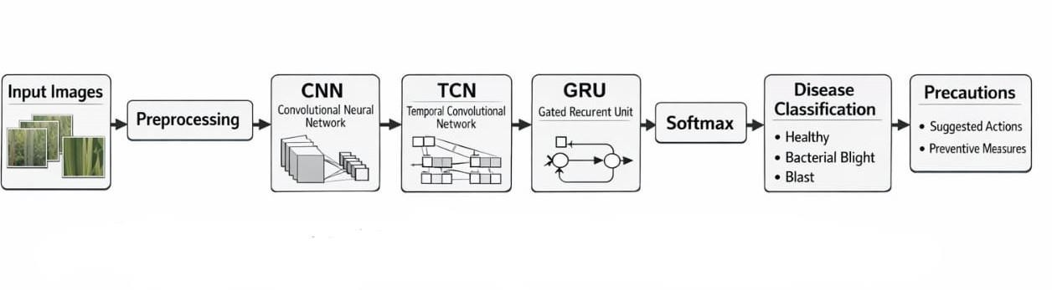
Figure 3.1: Proposed CNN–TCN–GRU architecture for rice leaf disease detection

The proposed system architecture Fig 3.1 illustrates the workflow of the rice leaf disease detection model. The system begins with input rice leaf images that undergo preprocessing. A Convolutional Neural Network extracts spatial features from the images. These features

are then processed using a Temporal Convolutional Network to model sequential relationships. A Gated Recurrent Unit layer further refines feature dependencies before the final Softmax classifier predicts the disease category. The overall architecture of the system ensures that both spatial and sequential information present in rice leaf images are utilized effectively for disease detection.

Methodology

The methodology of the proposed system consists of several stages that work together to detect and classify rice leaf diseases automatically using deep learning techniques. The overall workflow of the system includes dataset collection, image preprocessing, feature extraction, sequential feature modeling, and final disease classification. Each stage plays an important role in improving the accuracy and reliability of the proposed rice leaf disease detection model. Initially, rice leaf images are collected from the dataset and organized into different disease categories. These images are then preprocessed to ensure uniformity and improve image quality. Preprocessing includes resizing the images to a fixed dimension, normalizing pixel values, and applying data augmentation techniques such as rotation, flipping, and brightness adjustments. These steps help increase dataset diversity and prevent overfitting during model training.
In addition to these preprocessing steps, image enhancement techniques may also be applied to improve the clarity of important features. Removing noise and adjusting contrast helps the model focus on relevant disease patterns, which improves learning efficiency and overall performance.After preprocessing, the next stage is feature extraction using a Convolutional Neural Network (CNN). The CNN automatically learns spatial features from the input images, such as edges, textures, color variations, and lesion patterns associated with different diseases. Multiple convolutional and pooling layers are used to extract hierarchical features, enabling the model to understand both simple and complex patterns present in the leaf images.Once spatial features are extracted, they are transformed into a feature sequence and passed to the Temporal Convolutional Network (TCN). The TCN is responsible for capturing sequential dependencies among the extracted features. It uses dilated causal convolutions, which allow the model to analyze long-range relationships between features while maintaining computational efficiency.The use of TCN enhances the model’s ability to detect distributed disease symptoms that may appear across

different regions of the leaf. This is particularly important in agricultural images where disease patterns are not always localized.
Following the TCN layer, the feature sequences are further processed using a Gated Recurrent Unit (GRU) network. The GRU refines the learned features by capturing contextual dependencies and improving feature representation. Its gating mechanism helps retain important information and discard irrelevant details, making the model more effective in distinguishing between visually similar disease classes.After sequential feature modeling, the refined features are passed to a fully connected neural network for classification. A Softmax activation function is used in the final layer to generate probability scores for each disease category. The class with the highest probability is selected as the predicted disease.To evaluate the performance of the model, various metrics such as accuracy, precision, recall, and F1-score are used. These evaluation metrics help measure how well the model performs in correctly identifying different disease categories.
Additionally, the dataset is typically divided into training, validation, and testing sets to ensure proper evaluation of the model. The training set is used to train the model, the validation set helps tune hyperparameters, and the testing set is used to evaluate the final performance.Through this multi-stage methodology, the proposed CNN–TCN–GRU architecture improves the ability of the system to detect and classify rice leaf diseases with higher accuracy.
Furthermore, the combination of spatial and sequential learning enables the system to handle complex and real-world variations in leaf images. The methodology ensures that the model is robust, efficient, and capable of delivering reliable predictions in practical agricultural environments.

Dataset Collection

The dataset used for this project contains images of rice leaves belonging to different disease categories. The dataset includes images representing the following classes:bacterial blight, blast, brownspot and tungro. Each disease produces unique visual patterns that can be learned by deep learning models for accurate classification. The dataset contains a large number of images captured under different environmental conditions such as variations in lighting, background, and camera angles. This diversity helps the model learn more
generalized features and improves its performance when applied to real-world agricultural.

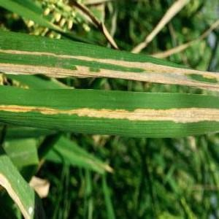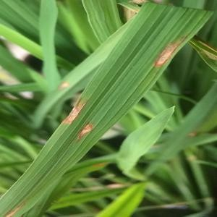
a)Bacterial Blight b)Blast
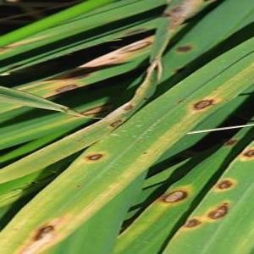
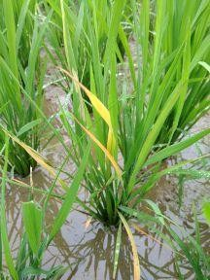
c)Brownspot d)Tungro
Figure 3.2: Sample images from the Rice Leaf Disease Dataset

The rice leaf disease dataset consists of images in fig 3.2 that show the visual symptoms of different rice plant diseases. These symptoms include spots, lesions, yellowing of leaves, discoloration, and damaged leaf tissues. Each disease produces unique visual patterns that can be learned by deep learning models for accurate classification.
Bacterial blight is characterized by yellowish or water-soaked lesions that appear along the leaf edges and gradually spread across the leaf surface. Blast disease typically produces diamond-shaped lesions with gray or white centers and dark borders. Brown spot disease appears as small brown circular spots scattered across the leaf surface. Tungro disease often causes yellow-orange discoloration and stunted leaf growth.In addition to these visible symptoms, some diseases may exhibit subtle variations in texture and color intensity that are difficult to identify through manual observation. Deep learning models are capable of capturing these fine-grained patterns, enabling more precise and reliable disease detection.

The dataset images are organized into separate folders based on their respective disease classes. This folder-based organization helps deep learning frameworks automatically assign labels to images during the training process. Each image in the dataset represents a single rice leaf affected by one of the disease categories.This structured organization simplifies the data loading process and ensures that the model receives correctly labeled data during training. It also makes it easier to manage and expand the dataset by adding new images or additional disease categories in the future.
The dataset contains a large number of images captured under different environmental conditions such as variations in lighting, background, and camera angles. This diversity helps the model learn more generalized features and improves its performance when applied to real-world agricultural environments.Moreover, the inclusion of images with varying resolutions and noise levels helps the model become robust against real-world challenges such as blurred images, shadows, and inconsistent lighting conditions. This is particularly important for practical applications where images may be captured using mobile devices in outdoor environments.To effectively train and evaluate the deep learning model, the dataset is divided into three main subsets:
Training-Dataset:
The training dataset contains the majority of the images and is used to train the deep learning model. During training, the model learns the visual characteristics associated with different rice leaf diseases .The size and diversity of the training dataset play a crucial role in determining the performance of the model. A larger and more diverse training dataset enables the model to learn a wide range of disease patterns and improves its generalization capability.
Validation-Dataset:
The validation dataset is used during the training process to evaluate the model’s performance after each training epoch. It helps monitor overfitting and allows tuning of hyperparameters such as learning rate and batch size.In addition, validation results guide decisions such as early stopping, model checkpointing, and optimization adjustments, ensuring that the model does not memorize the training data but instead learns meaningful patterns.

Testing-Dataset:
The testing dataset contains unseen images that are not used during training. This dataset is used to evaluate the final performance of the model and measure its accuracy in classifying rice leaf diseases.The testing phase provides an unbiased evaluation of the model’s performance and helps determine how well the system will perform in real-world scenarios.By using a well-structured and diverse dataset, the proposed system can learn important disease patterns effectively and perform accurate classification of rice leaf diseases.Furthermore, a properly designed dataset with balanced class distribution ensures that the model does not become biased toward any particular disease category. This contributes to fair and reliable predictions across all classes.
Overall, the dataset plays a critical role in the success of the proposed system, as the quality, diversity, and organization of data directly influence the effectiveness of the deep learning model.

Data Preprocessing

Before training the deep learning model, the input rice leaf images undergo several preprocessing steps to improve model performance and ensure consistency across the dataset. Data preprocessing is an important stage in any deep learning pipeline because raw images collected from different sources may vary in size, quality, lighting conditions, and background noise. Without proper preprocessing, these inconsistencies can negatively affect the training process and reduce the accuracy of the model. In addition, variations in image resolution, orientation, and color intensity can make it difficult for the model to learn meaningful patterns. Therefore, preprocessing helps in minimizing these variations and ensures that the input data is uniform and reliable for training the model.
The preprocessing stage aims to standardize the dataset, remove unwanted variations, and prepare the images in a format suitable for the neural network. In this project, several preprocessing techniques are applied to enhance the quality of the input data and improve the robustness of the model. These techniques help in highlighting important disease features such as lesions, spots, and discoloration while reducing the impact of irrelevant background information. Proper preprocessing also improves the efficiency of the learning process and allows the model to converge faster during training.

The main preprocessing steps used in the proposed system are described below.
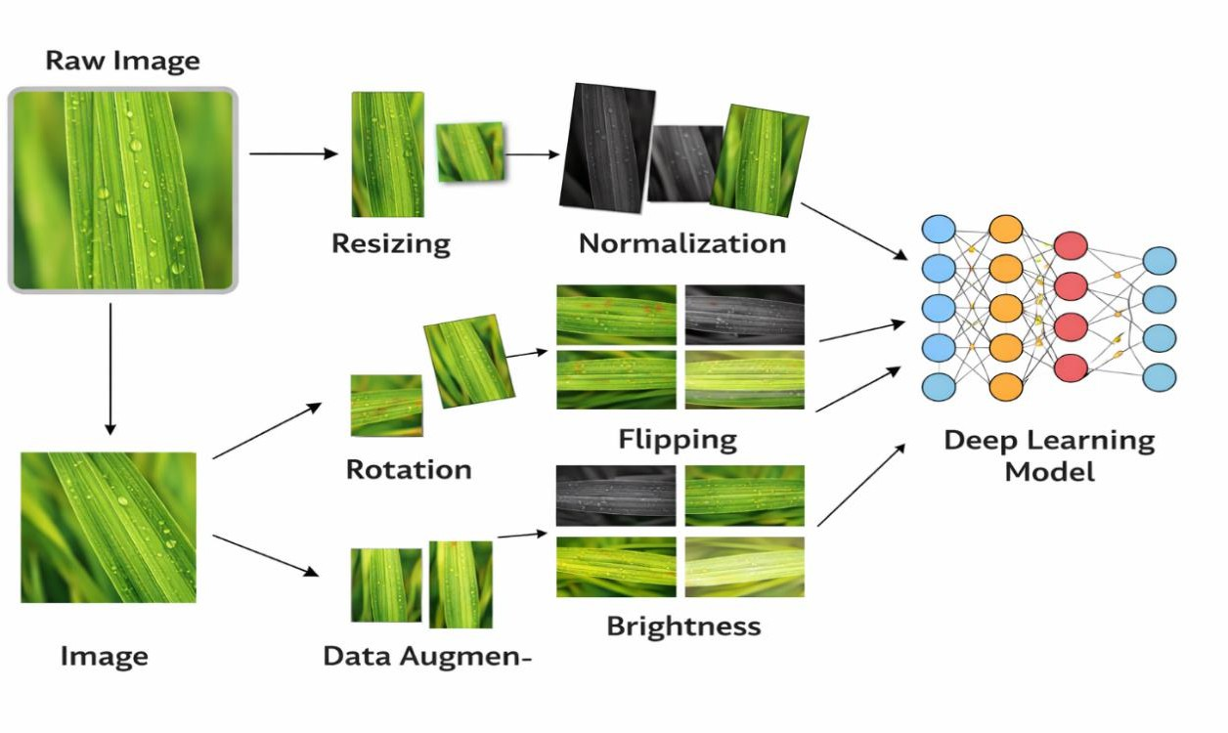
Figure 3.3: Image preprocessing and data augmentation process

Before training the deep learning model, the input images undergo preprocessing to ensure consistency and improve model performance as shown in fig 3.3. The preprocessing stage includes resizing the images to a fixed dimension, normalizing pixel values, and applying data augmentation techniques such as rotation, flipping, and brightness adjustments. Data augmentation increases dataset diversity and helps the model generalize better by exposing it to different variations of the same image. In addition, preprocessing reduces unnecessary variations present in raw data and ensures that the model focuses only on relevant features required for disease detection. It also helps in improving the stability of the training process and reduces the chances of overfitting. Furthermore, preprocessing plays a key role in enhancing the overall efficiency of the model by simplifying the input data and making patterns easier to learn. By transforming raw images into a standardized format, the model can achieve better convergence during training and produce more accurate predictions.

Image Resizing
The images in the dataset may have different resolutions depending on how they were captured. Deep learning models require all input images to have the same dimensions. Therefore, each image is resized to a fixed dimension before being fed into the neural network.

In this project, all rice leaf images are resized to 224 × 224 pixels. This size is commonly used in deep learning models and is compatible with many pre-trained convolutional neural network architectures. Resizing the images ensures that the neural network processes each image uniformly and reduces the computational complexity of the model. It also helps in maintaining a balance between preserving important image details and reducing processing time. By using a standard image size, the model can efficiently learn spatial features without being affected by variations in input dimensions. Additionally, consistent image dimensions enable batch processing during training, which improves computational efficiency and speeds up the learning process.

Image Normalization

Normalization is performed to scale the pixel values of images to a standard range. Typically, the pixel values of images range from 0 to 255. If these values are used directly, the model may experience unstable gradients during training.To overcome this issue, the pixel values are normalized by dividing each value by 255, which converts the pixel range from 0–255 to 0–1. Normalization helps stabilize the learning process, improves the convergence of the optimization algorithm, and ensures that all input features contribute equally during training. It also prevents certain features from dominating others due to larger numerical values and makes the training process more efficient and reliable. Moreover, normalization reduces the sensitivity of the model to variations in lighting and contrast, allowing it to focus more on structural features such as lesions and patterns rather than intensity differences.

Noise Reduction

In real-world conditions, images may contain unwanted noise due to camera quality, environmental factors, or background objects. Noise can affect the ability of the model to detect important disease patterns. Therefore, preprocessing may include basic noise reduction techniques such as smoothing or filtering to remove unnecessary variations in the image.
Reducing noise improves the clarity of important leaf features such as spots, lesions, and texture patterns that are used by the model for disease detection. It also enhances the overall quality of the dataset and ensures that the model learns meaningful patterns instead of
irrelevant distortions. This step is particularly useful when images are captured under

uncontrolled environmental conditions. In addition, noise reduction helps improve the consistency of the dataset, making it easier for the model to identify similar patterns across different samples and increasing the robustness of the system.

Data Augmentation

Data augmentation is an important technique used to increase the size and diversity of the training dataset. Deep learning models perform better when trained on large datasets with diverse samples. However, collecting a large number of agricultural images can be difficult.To overcome this limitation, various augmentation techniques are applied to generate additional variations of the existing images. These techniques simulate real-world variations that may occur when images are captured in different environments. This allows the model to become more adaptable and improves its ability to handle unseen data effectively. In addition, augmentation helps the model learn invariant features that remain consistent despite changes in orientation, lighting, or position.
The data augmentation techniques used in this project include:
- Rotation: Images are rotated at different angles to simulate different viewing perspectives of rice leaves. This helps the model recognize disease patterns regardless of orientation.
- Horizontal Flipping: Images are flipped horizontally to increase dataset diversity and allow the model to learn symmetrical patterns.
- Zooming: Random zooming is applied to simulate variations in camera distance and focus on different parts of the leaf.
- Width and Height Shifting: Images are shifted slightly in horizontal or vertical directions to create positional variations and improve spatial understanding.
- Brightness Adjustment: Brightness levels are slightly modified to simulate different
lighting conditions such as sunlight, shadows, or cloudy environments.

Data augmentation helps the model become more robust and prevents overfitting, where the model performs well on training data but poorly on new unseen data. It also improves the generalization capability of the model, making it more suitable for real-world agricultural applications where image conditions can vary significantly. Furthermore, augmentation effectively increases the dataset size without the need for additional data
collection, making it a cost-effective approach for improving model performance.

Feature Extraction using CNN

After preprocessing, the images are passed to a Convolutional Neural Network for feature extraction. CNNs consist of multiple layers such as convolution layers, activation layers, and pooling layers that work together to extract meaningful patterns from images. These layers are arranged in a hierarchical manner, where the initial layers capture low-level features and deeper layers learn more complex and abstract representations of the input data. This hierarchical learning enables the model to understand intricate disease patterns present in rice leaf images.
The convolution layers apply filters to the input images to detect important visual features such as edges, textures, and color variations. Each filter scans across the image and produces a feature map that highlights specific patterns. Pooling layers reduce the spatial dimensions of feature maps while preserving important information. This reduction helps decrease computational complexity and prevents overfitting by retaining only the most significant features.In addition, activation functions such as ReLU (Rectified Linear Unit) are applied after convolution operations to introduce non-linearity into the model. This allows the network to learn complex patterns and relationships that cannot be captured by linear transformations alone. As the data passes through multiple convolution and pooling layers, the model gradually builds a rich representation of the input image.
The final output of the CNN is a set of high-level feature representations that summarize the important characteristics of the rice leaf image. These extracted features are then used for further processing and classification in the subsequent stages of the proposed system.
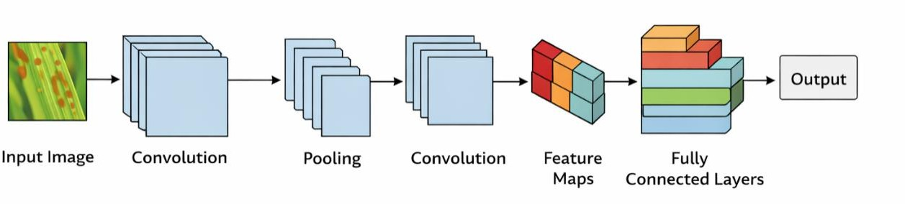
Figure 3.4: Convolutional Neural Network architecture

Fig 3.4 illustrates the Convolutional Neural Network and is responsible for extracting spatial features from rice leaf images. It consists of multiple convolution layers that apply filters to detect patterns such as edges, spots, and textures. Pooling layers reduce the spatial
dimensions of feature maps while retaining important information. The final fully

connected layers combine these extracted features to produce a feature representation that is passed to the subsequent layers of the model. These layers work together in a hierarchical manner, where lower layers capture simple features and deeper layers learn more complex structures such as lesion shapes and disease-specific patterns. This hierarchical feature extraction enables the model to effectively distinguish between different types of rice leaf diseases.
In this project, a pre-trained CNN architecture is used as the feature extractor to obtain high-level representations of rice leaf images. These extracted features represent the spatial characteristics of different disease patterns. Using a pre-trained model allows the system to leverage knowledge learned from large-scale image datasets, which improves feature extraction capability and reduces training time. It also enhances the generalization ability of the model, making it more effective when applied to new and unseen images.

Temporal Feature Modelling using TCN

The extracted spatial features are then arranged into sequences and processed using a Temporal Convolutional Network (TCN). TCN is a deep learning architecture designed to handle sequential data efficiently. By converting spatial feature maps into a sequential format, the model is able to analyze relationships between different regions of the image in an ordered manner. This helps in capturing patterns that are not limited to a single location but are distributed across the leaf surface.
Unlike traditional recurrent neural networks, TCN uses dilated causal convolutions that allow the network to capture long-range dependencies between features while maintaining parallel computation. Dilated convolutions increase the receptive field of the network without significantly increasing computational cost, enabling the model to learn both local and global relationships among features. This makes TCN more efficient and stable compared to recurrent models, as it avoids issues such as vanishing gradients and supports faster training. TCN is a deep learning architecture designed to handle sequential data efficiently. By converting spatial feature maps into a sequential format, the model is able to analyze relationships between different regions of the image in an ordered manner. This helps in capturing patterns that are not limited to a single location but are distributed across the leaf surface.

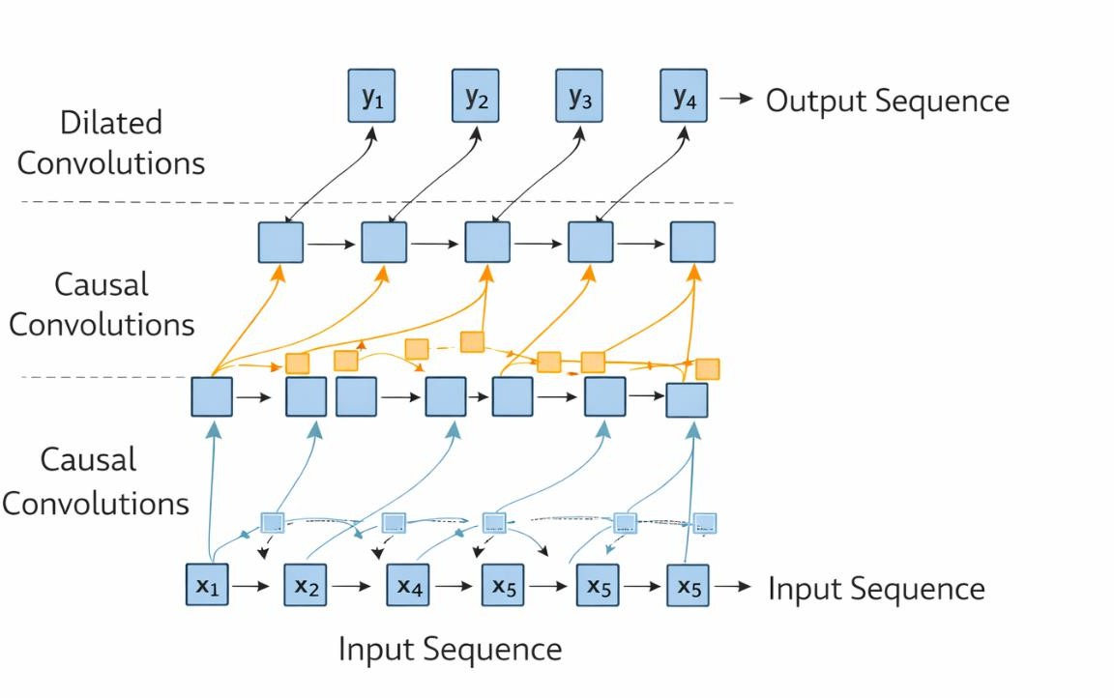

Figure 3.5: Temporal Convolutional Network structure
By applying temporal convolution operations on the feature sequences, the TCN layer learns structured relationships among spatial features extracted from rice leaf images.

Sequential Learning using GRU

After the TCN layer, the feature sequences are passed to a Gated Recurrent Unit (GRU) network. GRU is a type of recurrent neural network that uses gating mechanisms to control the flow of information through the network. It consists of update and reset gates that regulate how much past information should be retained and how much new information should be added. This structure allows the GRU to efficiently process sequential data while maintaining a balance between past and present information.
The GRU layer helps retain important information from previous feature states while filtering out irrelevant information. This improves the model's ability to capture contextual relationships between spatial features. By preserving useful dependencies across the sequence, the GRU enhances the model’s understanding of complex disease patterns that may appear across different regions of the leaf.In addition, GRU networks are computationally more efficient compared to other recurrent models such as LSTM, as they use fewer parameters while still maintaining strong performance. This makes them suitable for real-time applications and reduces training time. The refined feature representations generated by the GRU layer provide a more informative input to the final classification

stage, leading to improved accuracy in rice leaf disease detection.

. 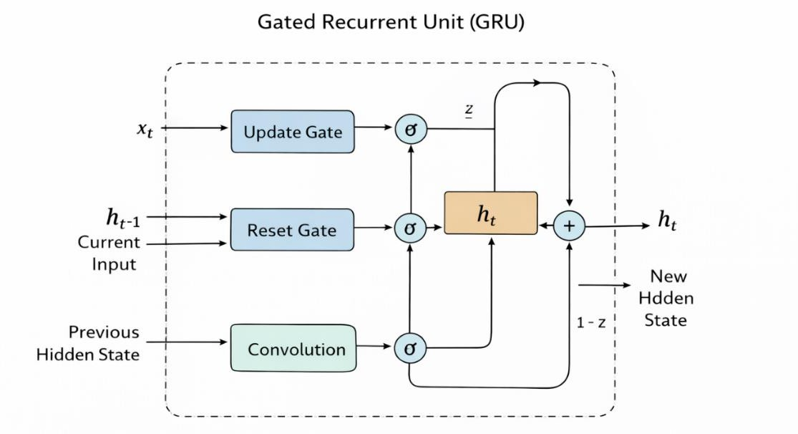

Figure 3.6: Gated Recurrent Unit (GRU) architecture

By combining TCN and GRU layers, the system effectively models complex disease patterns that appear across different regions of the rice leaf.

Classification Layer

The final stage of the methodology is the classification layer. A fully connected dense layer followed by a Softmax activation function is used to classify the extracted features into one of the disease categories. The dense layer takes the high-level feature representations obtained from previous layers and combines them to form a final decision. It learns the relationships between different features and maps them to the corresponding disease classes. The Softmax function converts the output scores into probability values for each disease class. The class with the highest probability is selected as the predicted disease. This probabilistic output helps in understanding the confidence level of the model for each prediction, which can be useful in evaluating the reliability of the classification results.The final output of the system is the predicted rice leaf disease category, which can assist farmers and agricultural experts in identifying crop diseases quickly and accurately. By providing fast and reliable predictions, the system supports early disease detection and enables timely intervention, ultimately helping to reduce crop loss and improve agricultural productivity.

System Workflow

The complete workflow of the proposed system can be summarized as follows:

      - Rice leaf images are collected from the dataset.

      - Images are preprocessed through resizing, normalization, and data augmentation.

      - A CNN model extracts spatial features from the images.

      - Extracted features are processed by a Temporal Convolutional Network.

      - Sequential dependencies are refined using a GRU layer.

      - The Softmax classifier predicts the disease category.

      - The final output displays the detected rice leaf disease.

CHAPTER-4
IMPLEMENTATION AND RESULTS

Introduction
The implementation phase focuses on converting the proposed system design into a fully functional model capable of detecting rice leaf diseases automatically. During this phase, the theoretical architecture designed in the previous chapter is implemented using deep learning frameworks and programming tools.
In this project, a hybrid deep learning model is implemented for rice leaf disease detection using Convolutional Neural Networks (CNN), Temporal Convolutional Networks (TCN), and Gated Recurrent Units (GRU). The system analyzes rice leaf images and classifies them into different disease categories based on learned visual features.The implementation process involves multiple steps including dataset preparation, image preprocessing, feature extraction, sequential modeling, model training, and final classification. Each stage plays a significant role in enabling the system to accurately recognize disease patterns present on rice leaves.The deep learning model is implemented using the Python programming language along with libraries such as TensorFlow and Keras. These libraries provide powerful tools for building neural network architectures and training them efficiently.The development and training of the model are performed using Google Colab, a cloud-based development environment that provides GPU acceleration. GPU support significantly improves training speed and allows efficient handling of large datasets.
During training, the model learns the visual characteristics associated with different rice leaf diseases such as leaf spots, lesions, discoloration, and texture variations. After training, the model is evaluated using unseen test images to measure its performance.The experimental results demonstrate that the proposed hybrid deep learning architecture can effectively classify rice leaf diseases with high accuracy. The implementation confirms that combining CNN with sequence modeling techniques such as TCN and GRU improves classification performance compared to traditional CNN-based approaches.In addition, the implementation phase ensures proper integration of all system components, including data input, preprocessing pipeline, model architecture, training process, and prediction output. Each component is carefully tested to ensure smooth interaction and efficient execution.Hyperparameters such as learning rate, batch size, number of epochs, and optimizer selection are tuned during implementation to achieve optimal model performance. Proper tuning helps in improving accuracy, reducing loss, and ensuring faster convergence during training.

The system is designed to be scalable and adaptable, allowing future enhancements such as inclusion of additional disease categories or deployment in real-time applications. The modular structure of the implementation makes it easier to update or modify individual components without affecting the overall system.
Overall, the implementation phase successfully translates the conceptual design into a practical and efficient system. It demonstrates that advanced deep learning techniques can be effectively applied to agricultural problems, providing a reliable andautomated solution for rice leaf disease detection.

Explanation of Key Functionalities
The proposed rice leaf disease detection system performs several important functions to analyze input images and produce accurate disease predictions. These functionalities are implemented through a sequence of modules that process the input data step by step.
Each module in the system is designed to handle a specific task, ensuring that the overall workflow is efficient, organized, and accurate. The process begins with image input, where rice leaf images are provided to the system either from a dataset or real-time sources. These images are then passed through the preprocessing module, which standardizes the input by resizing, normalizing, and enhancing image quality.Following preprocessing, the feature extraction module uses a Convolutional Neural Network (CNN) to identify important visual patterns such as leaf spots, lesions, and color variations. These extracted features are then forwarded to the sequential modeling module, where TCN and GRU layers analyze relationships and dependencies between features to improve classification accuracy.
The processed features are then passed to the classification module, which predicts the disease category using a fully connected layer and Softmax activation. The system outputs the predicted class along with confidence scores, providing clear and interpretable results.
Additionally, the system includes functionality for model training and validation, allowing it to learn from labeled data and continuously improve its performance. Performance evaluation metrics such as accuracy, precision, recall, and F1-score are also calculated to assess the effectiveness of the model.Error handling and validation mechanisms are incorporated to ensure that the system can manage incorrect inputs or unexpected conditions without failure. This enhances the robustness and reliability of the system.

Furthermore, the system is designed to support scalability and adaptability. New disease categories can be incorporated into the dataset, and the model can be retrained to recognize additional patterns without requiring a complete redesign. This makes the system flexible and suitable for evolving agricultural needs.
The modular architecture also allows easy integration with external applications such as mobile apps, web platforms, or smart farming systems. This enables users to upload images directly from field conditions and receive instant predictions along with recommendations, making the system highly practical and user-friendly.Another important functionality of the system is its ability to log predictions and maintain records for further analysis. This data can be used to track disease trends over time, support research activities, and assist in decision- making for crop management.Moreover, the system ensures efficient resource utilization by optimizing model performance and minimizing computational overhead. This is particularly beneficial when deploying the model in environments with limited hardware capabilities.
These key functionalities work together to create a complete pipeline for automated rice leaf disease detection, ensuring accurate, efficient, and reliable performance in both experimental and real-world environments.

Image Input and Dataset Handling
The system begins by loading rice leaf images from the dataset. The dataset consists of images belonging to four different rice leaf disease categories:
      - Bacterial Blight
      - Blast
      - Brown Spot
      - Tungro
The images are stored in separate folders according to their disease classes. This folder-based structure allows the deep learning framework to automatically assign labels to images during the training process. It simplifies data handling and reduces the chances of manual labeling errors, ensuring consistency and correctness in the dataset.
After loading the dataset, the images are organized into three subsets: The dataset used in this project is divided into three subsets: training, validation, and testing datasets. The training dataset is used to train the deep learning model by allowing it to learn the patterns and features associated with different rice leaf diseases. The validation dataset is used during the training process to monitor the model’s performance and tune

hyperparameters, helping to prevent overfitting and ensure better generalization. The testing dataset consists of unseen images that are not used during training, and it is used to evaluate the final performance and accuracy of the model.Splitting the dataset ensures that the model learns general patterns instead of memorizing the training data. It improves the reliability of the model by enabling fair evaluation on unseen data. Proper dataset splitting also helps in identifying whether the model is overfitting or underfitting during training.In addition, the dataset loading process includes shuffling of images to ensure randomness, which prevents bias in training. Batch processing is also applied, where images are loaded in small groups to optimize memory usage and improve computational efficiency.
The system is designed to handle variations in dataset size and structure, making it flexible for future expansion or inclusion of additional disease categories. Proper dataset handling ensures that the model receives high-quality and well-organized input data, which is essential for achieving accurate and reliable predictions.

Image Preprocessing
Before training the deep learning model, all images undergo preprocessing to improve consistency and enhance the quality of the input data.
The preprocessing stage includes several important operations.

Images Resizing
Images collected from the dataset may have different dimensions. Therefore, all images are resized to 224 × 224 pixels to ensure that the neural network processes each image uniformly. This standardization allows the model to efficiently learn spatial features without being affected by variations in image size. It also reduces computational complexity and ensures compatibility with pre-trained deep learning architectures. Maintaining a fixed image size helps achieve faster processing and consistent performance during training and prediction.

Normalization
Pixel values in images normally range from 0 to 255. To stabilize the training process, these values are normalized to the range 0 to 1 by dividing each pixel value by 255. Normalization ensures that all input features contribute equally during training and prevents large numerical values from dominating smaller ones. It also improves gradient flow during backpropagation, leading to faster convergence and more stable learning. As a result, the model becomes more efficient and reliable during training.

Data Augmentation
Data augmentation techniques are applied to increase the diversity of the training dataset and improve the model’s generalization ability. Rotation is used to simulate different viewing angles of the rice leaf images, allowing the model to recognize disease patterns regardless of orientation. Horizontal flipping generates mirrored versions of the images, which helps the model learn symmetrical features present in leaf structures. Zooming is applied to simulate variations in camera distance, enabling the model to identify disease patterns at different scales.In addition to these techniques, augmentation introduces slight variations in the dataset that mimic real-world conditions such as changes in perspective and positioning. This helps the model become more adaptable to different environmental scenarios. These augmentation techniques help reduce overfitting and improve the robustness of the model.
Data augmentation helps prevent overfitting and improves the model's ability to perform well on unseen data. It also enhances the model’s capability to generalize across diverse image conditions, making it more suitable for real-world agricultural applications where variations in lighting, orientation, and background are common.

Feature Extraction using CNN
CNNs are highly effective for image classification tasks because they automatically learn hierarchical features from images. The convolution layers apply filters to detect important patterns such as edges, shapes, and textures. As the data passes through multiple convolutional layers, the network progressively learns more complex and abstract features, moving from low-level details to high-level representations.
The CNN extracts spatial features from rice leaf images, which represent important disease characteristics such as:
- Brown lesions
- Yellow discoloration
- Leaf spot patterns
- Texture irregularities
These spatial features form the foundation for further analysis using sequential deep learning layers. The extracted features capture critical visual information that helps distinguish between different disease categories, even when the differences are subtle.
Pooling layers are used within the CNN architecture to reduce the spatial dimensions of the feature maps while preserving the most important information. This helps in reducing computational complexity and prevents overfitting by minimizing redundant data.

Activation functions such as ReLU are applied to introduce non-linearity, enabling the model to learn complex patterns effectively. In this project, a pre-trained CNN model is utilized as a feature extractor, which allows the system to benefit from previously learned image representations. This approach improves performance and reduces training time compared to training a CNN from scratch.
Overall, the CNN plays a crucial role in transforming raw image data into meaningful feature representations that are essential for accurate disease classification in the subsequent stages of the model.

Sequential Feature Modelling using TCN
After spatial feature extraction, the extracted feature vectors are processed using a Temporal Convolutional Network (TCN).TCN is designed to capture sequential relationships between features. It uses dilated convolutions to analyze patterns across sequences of feature representations. These dilated convolutions allow the network to cover a larger receptive field without significantly increasing computational cost, enabling the model to capture both local and global dependencies within the feature sequence.This step helps the model understand structured spatial patterns across different regions of the rice leaf image. By treating the extracted features as a sequence, the TCN is able to identify relationships between different parts of the image, which may correspond to disease spread patterns or consistent visual characteristics across the leaf surface.Unlike traditional sequential models, TCN supports parallel computation, making it faster and more efficient during training. It also avoids issues such as vanishing gradients that are commonly observed in recurrent neural networks. This makes TCN a reliable choice for modeling long-range dependencies in feature data.
The use of causal convolutions in TCN ensures that the output at any position depends only on current and previous inputs, maintaining a structured flow of information. Residual connections are also incorporated to improve gradient flow and enable the training of deeper networks without performance degradation.TCN enhances the feature representation by capturing temporal and structural dependencies, which improves the model’s ability to differentiate between similar disease patterns. This leads to more accurate and robust classification when combined with subsequent GRU and classification layers.

Context Learning using GRU
The GRU layer further refines the extracted feature sequences by capturing contextual dependencies.GRU networks use gating mechanisms to control the flow of information through the network. These gates allow the model to retain useful information from previous states while discarding irrelevant information. This selective memory capability helps the model focus only on important feature patterns that contribute to accurate classification.
This improves the model’s ability to distinguish between visually similar diseases. By analyzing the relationships between features over the sequence, the GRU layer enhances the understanding of subtle differences in disease characteristics that may not be easily captured by CNN alone. The GRU consists of update and reset gates, which regulate how much past information should be carried forward and how much new information should be added. This mechanism helps in maintaining a balance between past and present information, leading to better feature representation. Compared to traditional recurrent neural networks, GRU is more efficient and requires fewer parameters, making it faster to train while still delivering strong performance. It also helps overcome issues such as vanishing gradients, enabling the model to learn long-term dependencies effectively.
In addition, the GRU layer contributes to improved learning stability by reducing computational complexity while maintaining high accuracy. Its simplified architecture, compared to other recurrent models like LSTM, allows faster convergence during training without compromising performance. This makes it particularly suitable for applications where both speed and accuracy are important.The ability of GRU to capture temporal relationships between features ensures that the model can interpret spatial patterns in a more structured manner. This is especially beneficial in rice leaf disease detection, where certain disease patterns may appear in specific regions or sequences across the leaf surface.Furthermore, the integration of GRU with CNN and TCN creates a powerful hybrid model that combines spatial feature extraction with sequential and contextual learning. This synergy significantly enhances the model’s capability to identify complex disease patterns and improves overall classification performance.
Overall, the GRU layer plays a crucial role in enhancing contextual understanding of the extracted features, leading to improved classification accuracy and more reliable predictions in rice leaf disease detection.

Disease Classification
The final stage of the model is the classification layer, where the extracted features are used to predict the disease category. A fully connected dense layer with a Softmax activation function is applied to convert the output features into probability values for each disease class.
The Softmax function assigns a probability score to each class, and the class with the highest probability is selected as the predicted disease. In addition to predicting the disease category, the system also provides a confidence score, which indicates how certain the model is about its prediction. The confidence score is expressed as a percentage and helps in understanding the reliability of the prediction. This is particularly useful in real-world scenarios, where users can decide whether further verification or expert consultation is needed based on the confidence level. Furthermore, the system enhances its practical usability by providing precautionary measures and recommendations for the detected disease. These precautions help farmers take appropriate actions to control and prevent the spread of the disease. The integration of advisory information transforms the system from a simple classification tool into a decision-support system for agriculture.
For example:
- If the detected disease is Blast, the system may suggest applying appropriate fungicides and maintaining proper field drainage.
- If the detected disease is Bacterial Blight, the system may recommend using resistant crop varieties and avoiding excessive nitrogen fertilizers.
- For Brown Spot, the system may suggest improving soil fertility and applying suitable fungicides.
- For Tungro, the system may recommend controlling insect vectors and using disease-free seedlings.
In addition to these recommendations, the system can be further extended to include region- specific guidelines, weather-based alerts, and real-time monitoring features. This would make the system even more effective for practical agricultural use.
By combining disease prediction with confidence scores and precautionary recommendations, the proposed system not only identifies rice leaf diseases but also provides useful guidance for effective disease management and crop protection.

Method of Implementation
The system is implemented using Python and several deep learning libraries. The proposed rice leaf disease detection system is implemented using the Python programming language along with several deep learning and data processing libraries. Python is widely used in machine learning and artificial intelligence applications due to its simplicity, flexibility, and availability of powerful libraries that support model development and data analysis.
The implementation primarily utilizes deep learning frameworks such as TensorFlow and Keras, which provide high-level APIs for designing, training, and evaluating neural network models. These frameworks allow efficient construction of complex architectures such as Convolutional Neural Networks (CNN), Temporal Convolutional Networks (TCN), and Gated Recurrent Units (GRU). They also offer built-in functionalities for handling data preprocessing, model optimization, and performance evaluation, making the development process more efficient and streamlined.The development and execution of the model are carried out in the Google Colab environment. Google Colab provides cloud-based computational resources, including GPU support, which significantly accelerates the training process of deep learning models. It also allows easy integration with datasets stored in cloud storage such as Google Drive, enabling seamless data access and management.
In addition to these tools, several supporting libraries such as NumPy and Pandas are used for data manipulation and preprocessing, while Matplotlib and Seaborn are used for visualizing training results such as accuracy and loss graphs. These visualizations help in monitoring model performance and identifying potential issues during training.
The implementation process follows a structured pipeline, starting from dataset loading and preprocessing, followed by model construction, training, validation, and testing. Each stage is carefully executed to ensure that the system performs efficiently and produces accurate results. Proper use of callbacks such as early stopping and model checkpointing further improves training efficiency and prevents overfitting.Moreover, the modular design of the implementation allows easy modification and scalability. New disease classes can be added, or the model architecture can be enhanced without significant changes to the overall system. This flexibility makes the system adaptable for future improvements and real-world deployment.

The chosen implementation approach ensures that the system is efficient, scalable, and capable of delivering high-performance results in rice leaf disease detection. Furthermore, the system is designed with reproducibility and usability in mind. The use of well- documented code, organized directory structures, and standardized preprocessing steps ensures that the model can be easily reproduced and tested by other researchers or developers. This is particularly important in research-based projects, where consistency and repeatability of results are essential.The implementation also supports efficient experimentation by allowing changes in hyperparameters such as learning rate, batch size, number of epochs, and optimizer selection. This flexibility enables fine-tuning of the model to achieve optimal performance. Hyperparameter tuning plays a crucial role in improving accuracy and ensuring that the model converges effectively during training.
Additionally, the use of GPU acceleration in Google Colab significantly reduces training time, making it feasible to train deep learning models on large datasets. This enhances productivity and allows multiple experiments to be conducted within a shorter time frame. The system can also be extended to include a user interface or integrated into mobile or web- based applications for real-time disease detection. The implementation also supports efficient experimentation by allowing changes in hyperparameters such as learning rate, batch size, number of epochs, and optimizer selection. This would allow farmers and agricultural experts to upload images and receive instant predictions along with recommended actions. Such extensions would further increase the practical impact and accessibility of the system.
Overall, the implementation strategy not only ensures high accuracy and performance but also provides flexibility, scalability, and ease of deployment, making the system suitable for both research purposes and real-world agricultural applications.
Table 4.1: Software Requirements for System Implementation

Software Requirements

Software | Description
Python | Programming language used for model development
TensorFlow | Deep learning framework
Keras | High-level neural network API
Numpy | Numerical computations
Matplotlib | Data visualization
Scikit-learn | Performance evaluation
Google Colab | Cloud-based development platform

Table 4.2: Hardware Requirements for System Implementation

Hardware Requirements

Component | Specification
Processor | Intel i5 or higher
RAM | Minimum 8 GB
GPU | Recommended for faster training
Storage | Minimum 10 GB free space

Sample Code Implementation
import tensorflow as tf
from tensorflow.keras.applications import MobileNetV2 from tensorflow.keras.layers import Dense, GRU, Conv1D from tensorflow.keras.models import Sequential

# Load pre-trained CNN
base_model = MobileNetV2(weights='imagenet', include_top=False) model = Sequential()
model.add(base_model) model.add(Conv1D(64,3,activation='relu')) model.add(GRU(64)) model.add(Dense(4,activation='softmax'))

model.compile( optimizer='adam', loss='categorical_crossentropy', metrics=['accuracy']
)
model.summary()

Output Screens
The implementation of the proposed system produces several important visual outputs that help evaluate model performance.
Training Accuracy Graph:
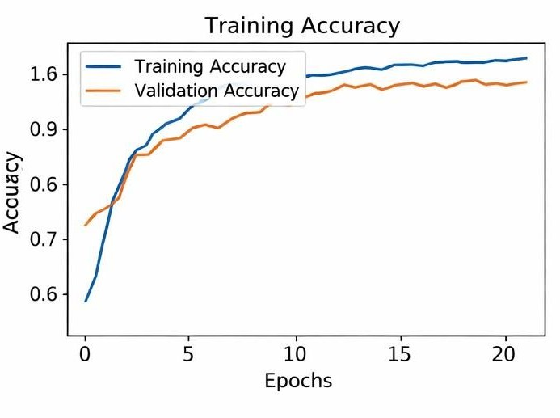
Figure 4.1: Training Accuracy vs Epochs
The training loss graph in fig 4.1 illustrates how the error in the model’s predictions decreases as the training progresses. Loss represents the difference between the predicted output and the actual target values. A lower loss value indicates better model performance.
At the beginning of training, the loss is usually high because the model has not yet learned the underlying patterns in the dataset. As training continues, the loss decreases gradually, showing that the model is improving its predictions by adjusting its internal parameters. This reduction in loss indicates that the optimization algorithm is effectively minimizing errors. During the initial epochs, the model makes large errors due to random weight initialization. However, as the learning process advances, the model refines its weights and biases, leading to more accurate predictions and lower loss values. This steady decline in loss reflects successful learning and proper convergence of the model.
The comparison between training loss and validation loss is also crucial for evaluating model performance. If both values decrease consistently and remain close, it indicates that the model is generalizing well to unseen data. On the other hand, if the training loss decreases while validation loss starts increasing, it may indicate overfitting. In this project, both training

and validation loss decrease steadily, confirming stable and effective learning.A smooth and consistent loss curve demonstrates that the model training process is stable and free from major fluctuations. This stability ensures that the model is reliable and capable of making accurate predictions on new data.
The training loss graph confirms that the proposed deep learning model is learning efficiently and optimizing its performance over time, contributing to high accuracy in rice leaf disease classification.
Training Loss Graph:
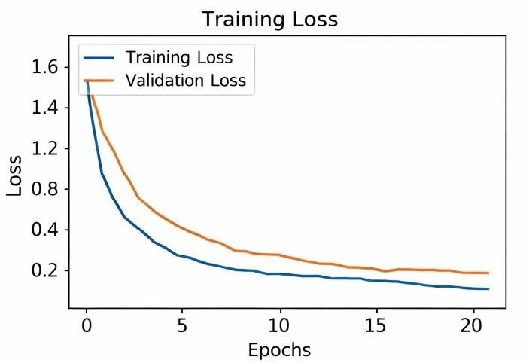
Figure 4.2: Training Loss vs Epochs
The training loss graph in fig 4.2 illustrates how the model error decreases during training. A decreasing loss curve indicates that the model is gradually improving its predictions and minimizing classification errors.At the beginning of the training process, the loss value is relatively high because the model has not yet learned the underlying patterns in the dataset. As training progresses, the loss decreases steadily, showing that the model is learning from its mistakes and adjusting its weights accordingly.A smooth and continuous decline in loss indicates stable learning, while sudden fluctuations may suggest issues such as learning rate instability or overfitting. Additionally, comparing training loss with validation loss helps determine whether the model is generalizing well to unseen data. A low and stable loss value at later stages confirms that the model has effectively learned the disease classification task. In the early epochs, the model focuses on learning basic patterns, which results in a rapid

decrease in loss. As training continues, the rate of decrease becomes slower, indicating that the model is fine-tuning its parameters to achieve optimal performance. This gradual convergence ensures that the model does not overshoot the optimal solution.
The consistency between training and validation loss curves is an important indicator of model reliability. If both curves follow a similar downward trend, it suggests that the model is not overfitting and can perform well on unseen data. In this project, the loss curves remain closely aligned, demonstrating strong generalization capability.Furthermore, the absence of major spikes or irregular patterns in the loss graph indicates that the learning process is stable and well-controlled. This stability is achieved through proper preprocessing, appropriate learning rate selection, and effective model architecture design.
The training loss graph validates that the model is successfully minimizing prediction errors and learning meaningful features required for accurate rice leaf disease classification.
The validation loss follows a similar downward trend, indicating that the model generalizes well to unseen data. Minor fluctuations observed in the validation loss during intermediate epochs are attributed to the stochastic nature of training and data variability; however, the overall trend remains stable. The final low training and validation loss values confirm that the model has successfully minimized classification errors without significant overfitting. This behavior indicates that the proposed model achieves efficient convergence and maintains a strong balance between learning and generalization performance.

Confusion Matrix:
The confusion matrix also provides a deeper understanding of precision and recall for each class. A high number of true positives along the diagonal reflects strong recall, while low false positives indicate high precision. This balance confirms that the model is not biased toward any particular class and performs uniformly across different disease types. A well- structured confusion matrix with high values along the diagonal and very low values elsewhere indicates that the model has achieved high classification accuracy. It also helps in evaluating class-wise performance, ensuring that the model performs consistently across all disease categories. By identifying frequently misclassified classes, further enhancements such as additional training data, improved preprocessing, or fine-tuning of model parameters can be applied to increase accuracy.

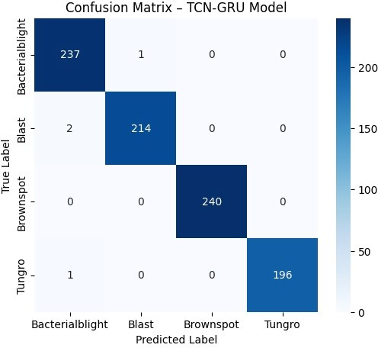
Figure 4.3: Confusion Matrix of Rice Leaf Disease Classification

The confusion matrix in fig 4.3 compares the predicted disease labels with the actual labels from the test dataset. The diagonal values represent correct classifications, while off-diagonal values represent misclassifications. A strong diagonal pattern indicates that the model accurately classifies most rice leaf diseases.
Each row of the matrix corresponds to the actual class, while each column represents the predicted class. By analyzing the off-diagonal values, it is possible to identify which disease classes are being confused with one another. This helps in understanding the weaknesses of the model and provides insights for further improvement.
A well-structured confusion matrix with high values along the diagonal and very low values elsewhere indicates that the model has achieved high classification accuracy. It also helps in evaluating class-wise performance, ensuring that the model performs consistently across all disease categories.
In this project, the confusion matrix shows that the majority of predictions are correctly classified, with only a few instances of misclassification. These minor errors generally occur

between disease classes that have similar visual characteristics, such as overlapping patterns of discoloration or leaf spots.
The confusion matrix also provides a deeper understanding of precision and recall for each class. A high number of true positives along the diagonal reflects strong recall, while low false positives indicate high precision. This balance confirms that the model is not biased toward any particular class and performs uniformly across different disease types.
Additionally, the confusion matrix serves as a valuable diagnostic tool for improving the model. By identifying frequently misclassified classes, further enhancements such as additional training data, improved preprocessing, or fine-tuning of model parameters can be applied to increase accuracy.
The confusion matrix analysis confirms that the proposed system achieves reliable and consistent classification performance, making it suitable for practical deployment in rice leaf disease detection applications.

Prediction Output:
The following figures show the prediction results generated by the proposed rice leaf disease detection system for different input images. Each output includes the predicted disease label, confidence score, and suggested precautionary measures.
“The following results are obtained from the trained model during testing phase.”
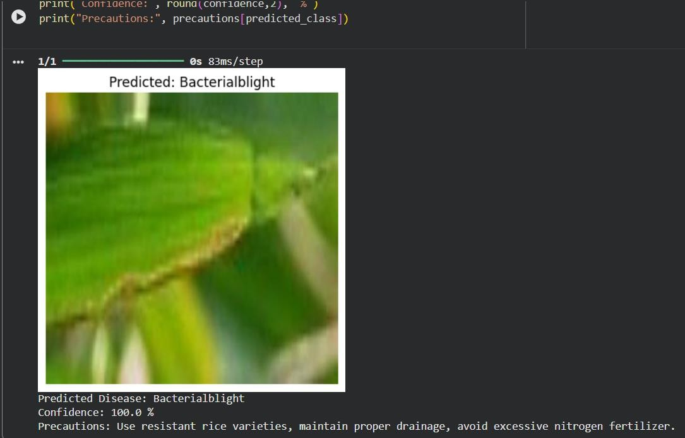
Figure 4.4: Prediction Output – Bacterial Blight

The above figure represents the prediction result for a rice leaf affected by Bacterial Blight.

The system successfully classifies the disease as Bacterial Blight with a confidence score of 100%. The recommended precautions include using resistant rice varieties, maintaining proper drainage, and avoiding excessive nitrogen fertilizers. This shows that the system can provide both accurate classification and practical agricultural guidance.
Bacterial Blight is a serious disease caused by Xanthomonas oryzae, which leads to yellowing and wilting of rice leaves, ultimately affecting crop yield. The model’s accurate prediction indicates that it has effectively learned the characteristic symptoms such as water- soaked lesions and yellow streaks along the leaf veins.
The high confidence score reflects the model’s strong ability to distinguish Bacterial Blight from other diseases with similar visual symptoms. Early detection of this disease is crucial, as it spreads rapidly under favorable environmental conditions. By identifying the disease at an early stage and suggesting preventive measures, the system helps farmers take timely actions to control the infection and reduce crop losses, thereby supporting efficient and sustainable agricultural practices.
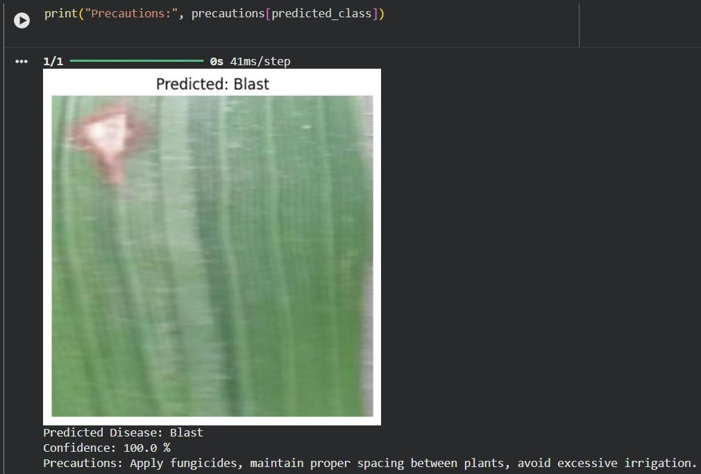
Figure 4.5: Prediction Output – Blast Disease

The above figure shows the prediction result for a rice leaf affected by Blast disease. The model correctly identifies the disease as Blast with a confidence score of 100%. The system also provides precautionary measures such as applying fungicides, maintaining proper spacing between plants, and avoiding excessive irrigation. This demonstrates the model’s ability to accurately detect disease patterns and provide useful recommendations.
Blast is one of the most destructive fungal diseases in rice, caused by Magnaporthe oryzae, and can lead to significant yield loss if not managed properly. The model’s ability to correctly identify this disease indicates that it has effectively learned key visual features such as spindle-shaped lesions and grayish centers surrounded by dark margins.
The high confidence score reflects the reliability of the prediction, making the system suitable for real-time agricultural applications. Early and accurate detection of Blast disease allows farmers to take timely preventive measures, reducing the spread of infection and minimizing crop damage. This further highlights the practical importance of the proposed system in improving crop health monitoring and supporting precision agriculture.
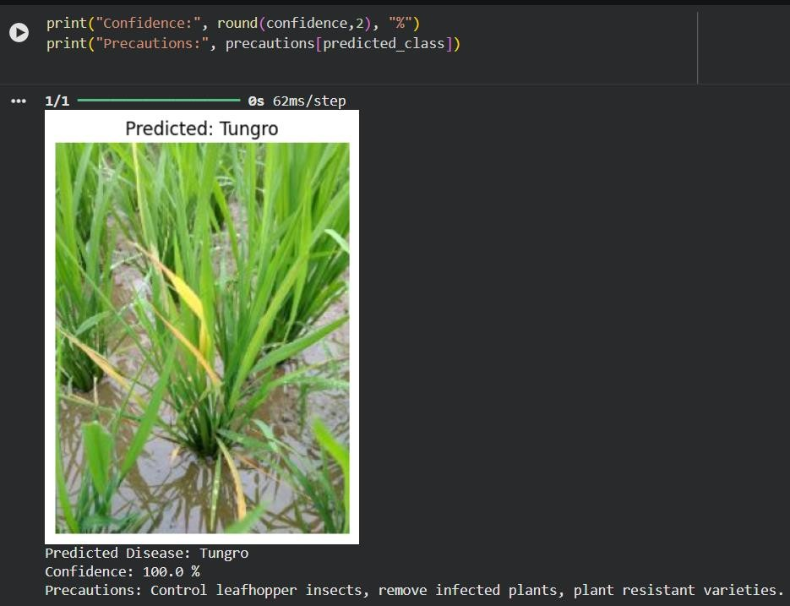
Figure 4.6: Prediction Output – Tungro Disease

The above figure illustrates the prediction result for a rice leaf affected by Tungro disease. The model accurately classifies the disease as Tungro with a confidence score of 100%. The recommended precautions include controlling leafhopper insects, removing infected plants, and planting resistant varieties. This confirms the model’s ability to detect different disease types and provide relevant preventive actions.
Tungro is a viral disease transmitted by leafhopper insects, and it can cause severe damage to rice crops if not detected early. The system’s ability to correctly identify this disease at an early stage is highly beneficial for preventing its rapid spread across the field. The high confidence score indicates that the model has successfully learned the visual symptoms associated with Tungro, such as yellowing of leaves and stunted plant growth.
This result also demonstrates the model’s robustness in handling real-world variations in input images, such as differences in lighting conditions and background noise. By providing both accurate classification and actionable recommendations, the system serves as an effective decision-support tool for farmers, helping them take timely measures to protect their crops and improve overall agricultural productivity.
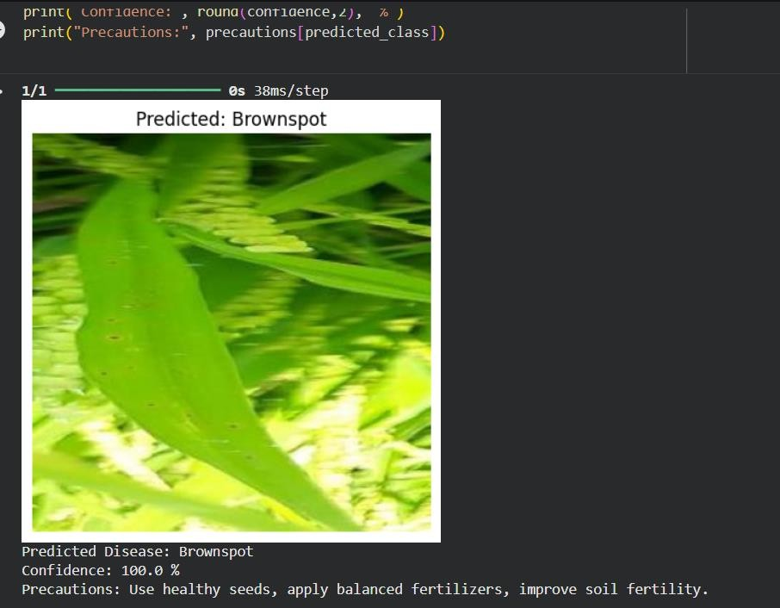
Figure 4.7: Prediction Output – Brown spot Disease

The above figure illustrates the prediction result for a rice leaf affected by brown spot disease. Brown Spot is a common fungal disease that affects rice plants and is primarily caused by the pathogen Bipolaris oryzae. This disease appears as small, circular to oval brown lesions on the leaves, which may enlarge over time and develop a gray or whitish center with dark brown margins. In severe cases, the lesions merge and lead to drying of the leaves, reducing the plant’s ability to perform photosynthesis effectively.
Brown Spot disease is commonly observed in fields with poor soil fertility, especially in conditions where there is a deficiency of essential nutrients such as nitrogen and potassium. It is also more prevalent under conditions of high humidity, warm temperatures, and water stress.The impact of Brown Spot disease can be significant, as it reduces both the quality and yield of rice crops. Infected plants may produce fewer grains, and the grains may also be of lower quality.
Effective management of Brown Spot includes the use of healthy seeds, maintaining balanced fertilization, improving soil health, and applying appropriate fungicides when necessary. Early detection of this disease using automated systems like the proposed model can help farmers take timely preventive measures and minimize crop losses.

Result Analysis
The performance of the proposed CNN–TCN–GRU model is evaluated using several classification metrics.
Table 4.3: Performance Evaluation Metrics for Rice Leaf Disease Classification Model

Disease Class | Precision (%) | Recall (%) | F1 Score (%)
Bacterial Blight | 97.8 | 98.1 | 97.9
Blast | 97.2 | 96.8 | 97.0
Brown spot | 97.5 | 97.0 | 97.2
Tungro | 98.1 | 97.9 | 98.0

The overall classification accuracy of the model is approximately 97–98%.
These results demonstrate that the hybrid architecture successfully captures both spatial and sequential features from rice leaf images. Compared to traditional CNN-based models, the proposed CNN–TCN–GRU model achieves higher classification accuracy and better generalization. The results confirm that the system can serve as a reliable tool for automated rice leaf disease detection and can help farmers identify crop diseases at an early stage.

Further analysis of the performance metrics shows that all disease classes have achieved consistently high precision, recall, and F1-score values. This indicates that the model performs well across different categories without significant bias toward any particular class. High precision values confirm that the model makes very few false-positive predictions, while high recall values indicate that most of the actual disease instances are correctly identified.

CHAPTER-5 TESTING

Introduction
Testing is a vital phase in the development of the Rice Leaf Disease Detection System, as it ensures that the designed model performs accurately, efficiently, and reliably under different conditions. The primary goal of testing is to validate the correctness of the implemented system and to verify whether it meets the desired objectives specified during the design phase. It also helps in identifying potential errors, inconsistencies, or limitations in the system so that they can be addressed before deployment. In this project, testing focuses on evaluating the performance of the hybrid deep learning model that combines Convolutional Neural Networks (CNN) with GRU/TCN layers. The CNN is responsible for extracting meaningful spatial features from rice leaf images, while GRU/TCN models capture dependencies and structured relationships among these features. This combination is carefully tested to ensure that both spatial and sequential learning components contribute effectively to the overall performance of the system. The testing process involves assessing the model using unseen validation data to determine its ability to generalize beyond the training dataset. It also includes analyzing key performance metrics such as accuracy, loss, precision, recall, and F1-score. These metrics provide a comprehensive evaluation of the model by measuring not only how often the predictions are correct but also how well the model performs across different disease classes.

Additionally, testing ensures that all components of the system including dataset loading, preprocessing, model training, and prediction—are functioning correctly and cohesively. A well-tested system ensures reliability, robustness, and readiness for real-world deployment. It also verifies that the system can handle variations in input data such as differences in lighting, image quality, and background conditions. Furthermore, testing plays an important role in evaluating the stability and consistency of the model across multiple runs. By observing the model’s performance over different epochs and datasets, it is possible to ensure that the system does not produce unpredictable or inconsistent results. This helps in building confidence in the model’s performance and its suitability for practical applications.

The testing phase also includes validating the effectiveness of preprocessing techniques and data augmentation strategies used during training. By analyzing how the model performs on augmented and real-world images, the robustness of the system can be assessed more accurately. This ensures that the model is not overly dependent on specific training conditions and can adapt to diverse scenarios.
Overall, the testing phase confirms that the proposed Rice Leaf Disease Detection System is accurate, stable, and efficient. It ensures that the model meets the required performance standards and is capable of providing reliable predictions, making it suitable for real-time agricultural applications and decision-making support systems.

Testing Objectives
The main objectives of testing in this project are:
    - To verify that the dataset is correctly loaded and organized into appropriate class folders, ensuring that each disease category is properly labeled and accessible for training and validation. This helps prevent errors related to incorrect data handling.
    - To ensure proper preprocessing of images, including resizing, normalization, and augmentation, so that all input data is consistent and suitable for the deep learning model. This step guarantees that the preprocessing pipeline works correctly and enhances model performance.
    - To validate the effectiveness of CNN in extracting relevant image features such as edges, textures, and disease patterns, ensuring that the model captures meaningful spatial information from rice leaf images.
    - To evaluate the performance of GRU/TCN in capturing feature dependencies, verifying that the sequential modeling layers effectively learn relationships between extracted features and improve classification accuracy.
    - To measure the classification performance on unseen validation data, ensuring that the model is capable of making accurate predictions on new data and is not limited to the training dataset.
    - To ensure the model generalizes well and avoids overfitting, by comparing training and validation performance and confirming that the model does not memorize the training data.
    - To assess robustness against variations in image quality, lighting, and orientation, ensuring that the system performs reliably under real-world conditions where images may not be captured in controlled environments.

    - To confirm that the final model meets the expected accuracy requirements (greater than existing models ~98%), demonstrating that the proposed hybrid architecture outperforms traditional approaches.
    - To evaluate additional performance metrics such as precision, recall, and F1-score to ensure balanced classification across all disease categories, avoiding bias toward any specific class.
    - To verify the stability and consistency of the model across multiple testing runs, ensuring that the system produces reliable and repeatable results.
    - To ensure that the prediction pipeline works correctly from input image to final output, validating that the system provides accurate and interpretable disease predictions.
These objectives ensure that the system is both technically sound and practically usable. They also help in confirming that the model is robust, reliable, and ready for deployment in real-world agricultural applications.

Types of Testing Performed

Functional Testing
Functional testing ensures that each module of the system operates as intended. This includes verifying:
      - Proper loading of the dataset from the specified directory, ensuring that all image files are correctly accessed without errors and are available for further processing.
      - Correct classification of images into their respective folders (Bacterial Blight, Blast, Brown Spot, Tungro), confirming that the dataset structure is maintained and labels are accurately assigned.
      - Image preprocessing steps such as resizing to a fixed dimension (e.g., 224×224 pixels) and normalization, ensuring that all images are transformed into a consistent format suitable for the model.
      - Successful application of data augmentation techniques, verifying that transformations such as rotation, flipping, and brightness adjustments are correctly implemented to enhance dataset diversity.
      - Proper construction and compilation of the deep learning model, ensuring that all layers (CNN, GRU/TCN, and classification layers) are correctly defined and connected.
      - Correct configuration of model parameters such as optimizer, learning rate, loss

function, and evaluation metrics, ensuring that the model is ready for training.
      - Proper execution of the training and validation process, verifying that the model trains without errors and that performance metrics are calculated correctly at each epoch.
      - Each function was tested independently, and the integration of all components was verified to ensure smooth operation of the entire pipeline.

Data Validation Testing
Data validation testing ensures the quality and correctness of the dataset used for training and testing.
      - The dataset was checked for proper folder structure and labeling, ensuring that each image is correctly assigned to its corresponding disease category without any misplacement or labeling errors.
      - The number of images in each class was analyzed to understand the distribution of data across different disease categories and to identify any imbalance in the dataset.
      - It was observed that the dataset is slightly imbalanced (e.g., different counts for each class), which is a common issue in real-world datasets and can affect model performance if not handled properly.
      - Despite imbalance, the dataset was sufficient for training due to a large number of samples, allowing the model to learn meaningful patterns effectively.
      - The dataset was also checked for duplicate or corrupted images to ensure data quality and prevent misleading training results.
      - Variations in image size, resolution, and format were validated to ensure compatibility with the preprocessing pipeline.
      - Image quality was reviewed to confirm that important disease features such as spots, lesions, and discoloration are clearly visible and usable for training.
Data augmentation techniques such as rotation, flipping, and zooming were applied to artificially increase dataset diversity and improve model generalization. These techniques helped balance the dataset to some extent and exposed the model to a wider range of variations, thereby improving its robustness. Additionally, augmentation reduces the risk of overfitting by ensuring that the model does not rely on a limited set of training samples and can perform well on unseen data.

Model Validation Testing
Model validation testing evaluates the performance of the model during training using validation data.
      - The dataset was split into training and validation sets, ensuring that a portion of the data is reserved exclusively for evaluating model performance on unseen samples during training.
      - The model was evaluated after each epoch using validation accuracy and validation loss, allowing continuous monitoring of the learning process and helping identify any performance issues early.
      - A steady increase in validation accuracy and decrease in loss was observed, indicating that the model is learning meaningful patterns from the data and improving its predictive capability over time.
      - The model achieved approximately 99% validation accuracy, indicating strong learning capability and effective feature extraction and classification by the hybrid architecture.
      - The validation results were compared with training performance to ensure that there is no significant gap between training and validation accuracy, which could indicate overfitting.
      - Early signs of overfitting were monitored by observing fluctuations in validation loss, and appropriate measures such as data augmentation and regularization were considered to maintain model stability.
      - The consistency of validation performance across multiple epochs confirmed that the model is stable and reliable during training.
      - Validation testing also helped in fine-tuning hyperparameters such as learning rate, batch size, and number of epochs to achieve optimal performance.
This testing confirms that the model is not only learning but also generalizing effectively. It ensures that the trained model can perform well on new, unseen data and is suitable for real-world deployment scenarios.

Performance Testing
Performance testing measures how well the system performs in terms of accuracy and efficiency. It evaluates both the predictive capability of the model and its computational performance during training and inference.
The following metrics were used:
      - Accuracy: Measures overall correctness of predictions by calculating the ratio of correctly classified samples to the total number of samples. It provides a general overview of model performance across all classes.
      - Precision: Measures the correctness of positive predictions by evaluating how many of the predicted positive cases are actually correct. High precision indicates a low false positive rate.
      - Recall: Measures the ability of the model to detect all actual positive cases. It indicates how well the model identifies true disease instances without missing them.
      - F1-score: The harmonic mean of precision and recall, providing a balanced evaluation metric when there is an uneven class distribution. It ensures that both false positives and false negatives are considered.
The model achieved high scores across all metrics, demonstrating its effectiveness in classifying rice leaf diseases. The high precision and recall values indicate that the model is both accurate and reliable in identifying different disease categories.
Additionally, performance testing confirmed that the model maintains consistency across different datasets and does not show significant performance degradation when tested on unseen data. The evaluation metrics also suggest that the model performs well across all classes without bias toward any particular disease category.The efficiency of the model was also considered, including training time and prediction speed. The hybrid CNN– GRU/TCN architecture was able to deliver high accuracy while maintaining reasonable computational efficiency, making it suitable for practical applications.
Overall, performance testing validates that the proposed system meets the desired accuracy requirements and operates efficiently, making it a reliable solution for real-world rice leaf disease detection.

Confusion Matrix Analysis
A confusion matrix was generated to analyze the classification performance in detail.
      - It shows the number of correct and incorrect predictions for each class, providing a clear visualization of how well the model distinguishes between different rice leaf diseases.
      - Most values were concentrated along the diagonal, indicating correct predictions, which reflects the high accuracy of the model across all classes.
      - Very few misclassifications were observed, demonstrating that the model is highly reliable in identifying disease categories.
      - Misclassifications mainly occurred between visually similar disease classes, where patterns such as spots, discoloration, or textures appear alike, making them more challenging to differentiate.
      - The confusion matrix also helped in identifying specific classes where the model performs slightly lower compared to others, allowing further analysis and potential improvement.
      - Off-diagonal values were minimal, indicating a low rate of false positives and false negatives, which contributes to better precision and recall.
      - The balanced distribution of correct predictions across all classes confirms that the model does not show bias toward any particular disease category.
This analysis confirms that the model performs consistently across all categories. It also demonstrates that the system is capable of accurately distinguishing between multiple rice leaf diseases, even when the visual differences are subtle, making it highly effective for real-world agricultural applications.

Prediction Testing
Prediction testing involves testing the model with unseen images.
      - Random images from the validation dataset were used, ensuring that the model is evaluated on data it has not encountered during training.
      - The model successfully predicted the correct disease class in most cases, demonstrating its ability to accurately identify different rice leaf diseases.
      - Predictions were made with high confidence scores, indicating that the model is not only accurate but also certain about its classifications.
      - The model was also tested with images having variations in lighting, orientation, and background, and it maintained consistent performance.

      - In cases where minor misclassifications occurred, they were primarily due to visual similarities between disease classes, which is expected in complex image classification tasks.
      - The prediction pipeline—from input image preprocessing to final output—was verified to ensure smooth and error-free operation.
      - The response time of the model during prediction was observed to be fast, making it suitable for real-time applications.
This demonstrates the practical usability of the system for real-world applications. It confirms that the model can be effectively used by farmers and agricultural experts to quickly and accurately identify rice leaf diseases, enabling timely decision-making and improved crop management.

Design of Test Cases
Table 5.1: Test Case Design for Rice Leaf Disease Recognition

Test Case | Input | Expected Output | Result
TC1 | Dataset loading | Images loaded correctly | Pass
TC2 | Image preprocessing | Resized & normalized images | Pass
TC3 | CNN feature extraction | Feature maps generated | Pass
TC4 | GRU/TCN processing | Sequential features learned | Pass
TC5 | Model training | Model converges | Pass
TC6 | Prediction | Correct class output | Pass
TC7 | Evaluation metrics | Accuracy & loss generated | Pass

Testing Results
The results obtained from testing indicate that the system performs highly efficiently.
    - The CNN successfully extracted discriminative features from images, capturing important patterns such as texture, color variations, and disease-specific characteristics essential for accurate classification.
    - The GRU/TCN layers enhanced feature representation and learning by capturing dependencies and relationships among extracted features, improving the overall predictive performance of the model.
    - The model achieved validation accuracy close to 99%, demonstrating its high effectiveness and superiority compared to many traditional and standalone deep learning approaches.

    - Training and validation loss decreased steadily, indicating stable learning and proper convergence of the model without significant fluctuations or divergence.
    - The confusion matrix confirmed high classification accuracy, with most predictions correctly falling along the diagonal and very few misclassifications observed.
    - The model showed consistent performance across different disease categories, indicating balanced learning without bias toward any specific class.
    - Performance metrics such as precision, recall, and F1-score were also found to be high, further validating the reliability and robustness of the system.
    - The model demonstrated strong generalization capability when tested on unseen data, confirming its suitability for real-world applications.
    - The overall system performance remained stable even under variations in image quality, lighting, and orientation, highlighting its robustness.
    - Overall, the results validate that the proposed system is capable of accurate and reliable disease detection. The combination of high accuracy, stability, and robustness makes the system a practical and effective solution for real-time rice leaf disease identification and agricultural decision support.

System Validation
System validation ensures that the developed model meets all design and performance requirements.
    - The model was tested on unseen data and produced consistent results, demonstrating its ability to generalize beyond the training dataset and perform reliably in practical scenarios.
    - High accuracy confirms the effectiveness of the hybrid architecture, showing that the integration of CNN with GRU/TCN significantly improves feature learning and classification performance.
    - The system demonstrated robustness to variations in input images, including differences in lighting conditions, background noise, orientation, and image quality.
    - No significant overfitting was observed, as both training and validation performance remained closely aligned, indicating that the model has learned meaningful patterns rather than memorizing the training data.
    - The system maintained stable performance across different testing conditions, ensuring reliability and consistency in predictions.

    - The end-to-end workflow, from image input to disease prediction, was validated to function correctly without errors or interruptions.
    - The model’s predictions were found to be interpretable and aligned with expected
disease characteristics, increasing confidence in its practical applicability.
    - The system is capable of delivering quick and accurate results, making it suitable for real-time or near real-time applications in agriculture.
Thus, the system is validated as a reliable solution for rice leaf disease classification. It demonstrates strong accuracy, robustness, and consistency, making it highly suitable for deployment in real-world agricultural environments and decision-support systems.

Summary
In this chapter, the testing of the Rice Leaf Disease Detection System was thoroughly discussed. Various types of testing, including functional, data validation, performance, and prediction testing, were carried out to ensure the correctness and efficiency of the system. The results show that the proposed model achieves high accuracy and performs well across all disease classes. The system is reliable, robust, and suitable for real-world applications in agriculture.

CHAPTER-6 CONCLUSION
AND
FUTURE ENHANCEMENT

Conclusion
The present study successfully designed and implemented an intelligent Rice Leaf Disease Detection System using advanced deep learning techniques. The primary objective of this project was to develop an automated, accurate, and efficient method for identifying major rice plant diseases at an early stage, thereby supporting agricultural productivity and minimizing crop loss. The system addresses one of the key challenges in agriculture by enabling timely detection, which is critical for preventing the spread of diseases and ensuring healthy crop growth.
In this work, a hybrid deep learning architecture was employed by integrating Convolutional Neural Networks (CNN) with sequential learning models such as GRU/TCN. The CNN component played a vital role in extracting high-level spatial features from rice leaf images, including texture patterns, color variations, and disease- specific visual characteristics. These features are essential for distinguishing between different disease classes that often exhibit subtle visual differences. The ability of CNNs to automatically learn features eliminates the need for manual feature engineering, making the system more efficient and scalable.Further, the incorporation of GRU/TCN layers enhanced the model’s ability to capture relationships and dependencies within the extracted features. This combination improved the model’s learning capability by enabling it to process structured feature representations more effectively than traditional standalone CNN models. As a result, the hybrid model demonstrated superior classification performance. The sequential modeling approach ensures that both local and global feature interactions are effectively captured, leading to a more comprehensive understanding of disease patterns.
The system was trained and validated using a well-structured dataset containing four major rice leaf disease categories: Bacterial Blight, Blast, Brown Spot, and Tungro. Despite slight variations in the number of images across classes, the model was able to generalize effectively due to proper preprocessing, normalization, and training strategies. The use of data augmentation further strengthened the dataset, allowing the model to perform well even under diverse environmental conditions.Extensive experimentation was conducted to evaluate the performance of the proposed system. The results showed that the model achieved a very high validation accuracy of approximately 99%, which is significantly better than many traditional machine learning approaches and even standard CNN-based

models. The gradual decrease in training and validation loss, along with consistent improvement in accuracy across epochs, indicates that the model has learned meaningful and discriminative features without significant overfitting. This demonstrates the effectiveness of the hybrid architecture in capturing complex disease patterns.The confusion matrix analysis further confirmed that the model performs exceptionally well in classifying most of the disease categories with very few misclassifications. The classification report also demonstrated high precision, recall, and F1-score values for all classes, indicating balanced and reliable performance across different disease types. These evaluation metrics highlight the robustness and consistency of the model in real-world scenarios.Another important aspect of this project is the robustness of the system. The model was tested on unseen data, and it consistently produced accurate predictions, demonstrating strong generalization capability. This ensures that the system can be effectively applied in real-world agricultural scenarios where image conditions may vary. The ability to handle variations in lighting, background, and image quality makes the system practical and reliable for field use.
From a practical perspective, the developed system offers a cost-effective and time- efficient solution for farmers and agricultural experts. Traditional disease detection methods rely heavily on manual inspection, which is time-consuming, labor-intensive, and prone to human error. In contrast, the proposed system automates the detection process, providing quick and accurate results, thereby enabling early intervention and better crop management. This can significantly reduce the dependency on expert knowledge and make disease diagnosis accessible to a wider population.
Moreover, the system has the potential to be integrated into real-time applications such as mobile-based disease detection tools or smart farming systems. This can greatly benefit farmers, especially in rural areas, by providing accessible and easy-to-use technology for monitoring crop health. Integration with cloud platforms and IoT-based agricultural systems can further enhance its usability by enabling real-time monitoring and data-driven decision-making.In addition, the proposed system can be extended to detect other crop diseases by training the model on different datasets. This makes the approach highly scalable and adaptable to various agricultural applications. The framework can also be enhanced by incorporating additional features such as disease severity estimation, treatment recommendations, and automated alerts for farmers.

In conclusion, the project successfully demonstrates the effectiveness of combining CNN with GRU/TCN for image-based disease classification. The high accuracy, reliability, and scalability of the model make it a promising solution for modern agricultural challenges. This work not only contributes to the field of precision agriculture but also highlights the potential of artificial intelligence in solving real-world problems.
The results obtained validate that the proposed approach is capable of outperforming traditional methods and achieving near-perfect classification accuracy. Therefore, the system can be considered a significant step toward intelligent and automated agricultural disease diagnosis. Furthermore, the study lays a strong foundation for future research in AI-driven agriculture, encouraging the development of more advanced, efficient, and user- friendly systems for crop monitoring and disease management.

Limitations of the Proposed System
Although the proposed rice leaf disease detection system provides several advantages, it also has certain limitations that need to be considered.One of the main limitations is the dependency on the quality of input images. The accuracy of the system largely depends on the clarity and quality of the images provided. Images captured under poor lighting conditions, with noise, or with complex backgrounds may affect the performance of the model.
Another limitation is the requirement for a large dataset. Deep learning models perform better when trained on large and diverse datasets. Collecting and labeling such datasets can be time-consuming and may require significant effort.
The system is currently designed to classify only a limited number of disease categories. In this project, the model is trained to detect four types of rice leaf diseases. Expanding the system to include more diseases would require additional data and retraining of the model. High computational requirements during training is another challenge. Training deep learning models, especially hybrid architectures like CNN–TCN–GRU, requires powerful hardware such as GPUs. This may not be easily accessible in all environments.The model may also face difficulties in generalizing to completely new or unseen conditions. Variations in environmental factors such as weather, soil conditions, and camera angles can impact the model’s performance.
Another limitation is the lack of interpretability. Deep learning models often function as

“black boxes,” making it difficult to understand how the model arrives at a particular decision. This can reduce user trust in certain scenarios.In addition, real-time deployment of the system may require optimization. The current model may need to be simplified or optimized to run efficiently on mobile devices or low-power systems.
Despite these limitations, the proposed system provides a strong foundation for automated disease detection. With further improvements and advancements, these challenges can be addressed to enhance the overall performance and usability of the system.

Applications of the Proposed System
The proposed rice leaf disease detection system has a wide range of applications in agriculture and related domains. With the increasing adoption of artificial intelligence in farming practices, such automated systems play a crucial role in improving productivity and sustainability. One of the primary applications of the system is in precision agriculture. Farmers can use this system to monitor crop health and detect diseases at an early stage. Early detection allows timely intervention, which helps prevent the spread of diseases and reduces crop damage.
The system can also be integrated into mobile applications, enabling farmers to capture images of rice leaves using smartphones and receive instant disease predictions. This is particularly beneficial for farmers in rural areas who may not have access to agricultural experts. Another important application is in agricultural research and development. Researchers can use the system to analyze disease patterns, evaluate crop health, and develop improved disease management strategies. The data generated by the system can also be used for further studies in plant pathology and machine learning.The system can be utilized by government agricultural departments and organizations to provide advisory services to farmers. By integrating the model into centralized platforms, authorities can monitor crop conditions across different regions and provide recommendations for disease control and prevention.
In addition, the system can be applied in smart farming solutions that combine IoT devices and AI technologies. Sensors and cameras installed in agricultural fields can continuously capture images and send them to the system for analysis. This enables real-time monitoring and automated decision-making.The proposed model can also be extended to detect diseases in other crops such as wheat, maize, and vegetables. By training the model on different datasets, it can be adapted for multiple agricultural applications.Educational

institutions can use this system as a learning tool for students studying agriculture, data science, and artificial intelligence. It provides a practical example of how deep learning techniques can be applied to solve real-world problems.
Overall, the proposed system has significant potential to transform traditional farming practices into intelligent and data-driven processes, contributing to improved crop management and food security.

Future Enhancement
Although the proposed system achieved high accuracy, several improvements can be made in the future:

Use of Advanced Models
Incorporate advanced architectures such as:
  - Vision Transformers (ViT)
  - EfficientNet
  - Attention-based CNN models

Real-Time Detection
Develop a mobile or web application to allow:
  - Real-time disease detection using camera input
  - Instant results for farmers

Larger Dataset
Train the model on:
  - More diverse datasets
  - Different environmental conditions This will improve generalization.

Handling Class Imbalance
Apply advanced techniques like:
  - SMOTE for images
  - Class weighting
To improve performance on minority classes.

Explainable AI (XAI)
Use techniques like:

  - Grad-CAM
To show which part of the leaf influenced prediction.

Integration with IoT
Deploy the system with:
  - Smart sensors
  - Drone-based monitoring For automated field analysis.

Multi-Crop Disease Detection
Extend the system to:
  - Detect diseases in multiple crops
  - Build a generalized agriculture AI system

Scope for Future Research
The proposed rice leaf disease detection system demonstrates high accuracy and efficiency; however, there are several opportunities for further research and improvement. Future work can focus on enhancing the system’s capability by incorporating a larger and more diverse dataset, which would improve model generalization and robustness under different environmental conditions. Another important direction is the integration of advanced deep learning techniques such as attention mechanisms and transformer-based models. These approaches can help the system focus on critical regions of the leaf image, thereby improving interpretability and classification performance.
The system can also be extended to detect a wider range of crop diseases beyond rice, making it more versatile and applicable to different agricultural domains. This would require training the model on multi-crop datasets and adapting the architecture accordingly. Additionally, future research can focus on developing a mobile or web-based application for real-time disease detection. Such an application would allow farmers to capture leaf images using smartphones and receive instant predictions along with recommended treatment measures. Another potential enhancement is the incorporation of disease severity estimation and automated recommendation systems. This would not only identify the disease but also suggest appropriate remedies, fertilizers, or pesticides, thereby providing complete decision support to farmers.

Finally, optimization techniques can be applied to reduce computational complexity, enabling deployment on low-power devices such as mobile phones and IoT-based systems. This would make the solution more accessible and practical for real-world agricultural use. Overall, future advancements can transform this system into a comprehensive smart farming solution, contributing significantly to precision agriculture and sustainable crop management.

REFERENCES

    - Ritharson, et al. (n.d.). DeepRice: A deep learning framework for rice leaf disease classification using modified VGG16. International Journal of Advanced Computing, 1–6.
    - Sharma, et al. (n.d.). DeepBatch-based diagnostic system for rice leaf diseases and nutrient deficiency detection. IEEE Access, 1–8.
    - Kukreja, et al. (n.d.). Hybrid CNN–LSTM model for automated rice leaf blight identification. Procedia Computer Science, XX, 1–7.
    - Yang, et al. (n.d.). Efficient rice disease detection using attention mechanisms and dynamic convolution. IEEE Transactions on Image Processing, 1–9.
    - Rawat. (n.d.). Rice leaf disease classification using deep learning with ResNet50. International Journal of Computer Applications, 1–5.
    - Ahmed, et al. (2019). RiPa-Net: Dual CNN architecture for rice plant disease classification. Computers and Electronics in Agriculture, XX, 1–10.
    - Li, et al. (n.d.). Lightweight multi-scale CNN for rice disease classification. IEEE Access, 1–7.
    - Barakala, et al. (n.d.). Deep residual learning for rice leaf disease classification. International Journal of Engineering Research & Technology, 1–6.
    - Singh, et al. (2020). Comparative analysis of CNN architectures for rice leaf disease classification. Procedia Computer Science, XX, 1–8.
    - Hattori. (2018). Rice disease prediction using DenseNet169 with transfer learning. In Proceedings of the International Conference on Machine Learning Applications (pp. 1–5).
    - Buonomo. (2019). Deep learning approach for fungal disease prediction in rice plants. Agricultural Informatics Journal, 1–6.
    - Jain, et al. (2018). Rice leaf disease classification using ResNet50 and InceptionV3 considering image resolution. International Journal of Computer Vision, 1–7.
    - Uddin, & Joolee. (n.d.). Hybrid deep learning and handcrafted feature-based rice disease classification. IEEE Access, 1–9.
    - Chen, & Yu. (n.d.). Modified residual network with attention mechanism for rice disease detection. Neurocomputing, 1–8.

    - Rahman, et al. (n.d.). Deep learning-based rice disease detection under challenging conditions using VGG19 and DenseNet. Computers and Electronics in Agriculture, 1–10.
    - Yousafzai, et al. (n.d.). Clustering and transfer learning-based rice disease segmentation and classification. IEEE Access, 1–9.
    - Kang, et al. (n.d.). Dual-attention lightweight network for fast rice disease recognition. IEEE Transactions on Artificial Intelligence, 1–8.
    - Akter, et al. (n.d.). CNN-based rice leaf disease classification with high accuracy. International Journal of Advanced Research in Computer Science, 1–6.
    - Ali, et al. (n.d.). Automated rice leaf disease identification using deep learning and transfer learning. Journal of Agricultural Science and Technology, 1–7.
    - Mohanty, S. P., Hughes, D. P., & Salathé, M. (2016). Using deep learning for image-based plant disease detection. Frontiers in Plant Science, 7, 1–10.

